## The value of monitoring in efficiently and adaptively managing biotoxin contamination in marine fisheries

Christopher M. Free1,2*, Vera L. Trainer3

1 Bren School of Environmental Science and Management, University of California, Santa Barbara, Santa Barbara, CA, 93106, USA

2 Marine Science Institute, University of California, Santa Barbara, Santa Barbara, CA, 93106, USA

3 Environmental and Fisheries Science Division, Northwest Fisheries Science Center, National Marine Fisheries Service, National Oceanic and Atmospheric Administration, Seattle, WA, 98112, USA

**\* Corresponding author:** Bren School of Environmental Science and Management, University of California, Santa Barbara, 2400 Bren Hall, Santa Barbara, CA 93106-5131; 610-999-4732; cfree14@gmail.com

### Abstract (245 words)

Harmful algal blooms (HABs) can produce biotoxins that accumulate in seafood species targeted by commercial, recreational, and subsistence fisheries and pose an increasing risk to public health as well as fisher livelihoods, recreational opportunities, and food security. The impacts of HABs are expected to worsen under climate change highlighting a need to design biotoxin monitoring and management programs that eliminate public health risk with minimal impacts to the fishing communities that underpin coastal livelihoods and food systems. We review the history of domoic acid monitoring and management in the U.S. West Coast Dungeness crab fishery and highlight three adaptive changes made to these programs that efficiently manage mounting HAB risk: (1) expanded spatial-temporal frequency of monitoring; (2) delineation of clear management zones; and (3) legalization of evisceration orders as a potential management option. We then use simulation models grounded in historical data to measure the value of monitoring information in facilitating efficient domoic acid management. We confirm that monitoring surveys sampling 6 crabs (the current protocol) have high power to correctly diagnose contamination levels. Across a range of contamination scenarios, we find that increasing the spatial-temporal frequency of monitoring allows management to more quickly respond to changing toxin levels and to prevent public health risk with the least impact on fishing opportunities. Our results highlight the underutilized role of simulation testing and power analysis in designing efficient biotoxin monitoring programs, demonstrating the credibility of these programs to stakeholders, and justifying their expense to policymakers.

**Keywords (6 maximum):** harmful algal blooms, *Pseudo-nitzschia,* domoic acid, amnesic shellfish poisoning, Dungeness crab, *Metacarcinus magister*

### Highlights (3-5 bullet points, 85 characters each)

* Efficient biotoxin management prevents public health risk at least cost to fishers
* Evisceration orders are useful tools for efficient biotoxin management
* Clearly delineated management zones promote predictable management
* High frequency monitoring (spatially/temporally) enables efficient management
* Simulation testing and power analysis should be the first step in survey design

### 1. Introduction (1503 words)

Harmful algal blooms (HABs) represent an increasingly significant threat to fisheries and aquaculture globally. They are increasing in size, frequency, and duration due to the combined effects of eutrophication and climate change [(Glibert, 2020; Hallegraeff, 2010, 1993; Van Dolah, 2000)](https://www.zotero.org/google-docs/?qMDy9v) and these trends are expected to persist or worsen under continued climate change (“high confidence” in [(IPCC, 2019)](https://www.zotero.org/google-docs/?XTAh0U)). Some HABs are harmful because they produce toxins that accumulate in species harvested by fisheries and aquaculture and can cause human illness or mortality when consumed in high doses [(Grattan et al., 2016)](https://www.zotero.org/google-docs/?0Z42A8). As a result, toxin levels in vulnerable seafood species are closely monitored and elevated levels often trigger the closure of fisheries and aquaculture operations. Closures undermine the economic, nutritional, and sociocultural value of these food systems [(Bauer et al., 2010)](https://www.zotero.org/google-docs/?syoKVb); designing biotoxin monitoring and management programs that eliminate public health risk with minimal impacts to fishing and aquaculture communities is therefore critical to maintaining their viability in a changing climate.

On the North American West Coast, diatoms in the *Pseudo-nitzschia* genus can produce a neurotoxin called domoic acid that, when consumed by humans in elevated levels, can cause amnesic shellfish poisoning (ASP). The symptoms of amnesic shellfish poisoning range from gastrointestinal issues (e.g., stomach pain, vomiting, diarrhea, etc.) to neurological issues (e.g., headaches, dizziness, confusion, memory loss, seizures, etc.) to, in rare cases, death [(Teitelbaum et al., 1990)](https://www.zotero.org/google-docs/?LTlIWq). The first cases of amnesic shellfish poisoning and its linkage to *Pseudo-nitzschia* and domoic acid were documented in eastern Canada in 1987 [(Bates et al., 1989; Perl et al., 1990; Wright et al., 1989)](https://www.zotero.org/google-docs/?eV4Hey) and domoic acid contamination has been monitored in commercially and recreationally harvested seafood species on the U.S. West Coast since 1991 [(CA-OST, 2016a)](https://www.zotero.org/google-docs/?CIF412). Domoic acid commonly enters the food web through filter feeders such as mussels, clams, and anchovies (more rarely) and then into predators such as crabs, lobsters, and fish (more rarely) [(Lefebvre et al., 2002)](https://www.zotero.org/google-docs/?SY186b). As a result, clams, mussels, and crustaceans generally exhibit the highest risk of contamination and receive the greatest level of monitoring, and their fisheries and farming operations generally receive the greatest regulatory oversight.

In 2015, a marine heatwave colloquially known as “the blob” caused a *Pseudo-nitzschia* bloom of unprecedented size and duration [(McCabe et al., 2016; McKibben et al., 2017)](https://www.zotero.org/google-docs/?AngUfI). The bloom spanned from Baja to Alaska and resulted in prolonged closures of commercial and recreational fisheries along the entire coast, especially in California [(Ekstrom et al., 2020)](https://www.zotero.org/google-docs/?d0qyu9). The California Dungeness crab fishery, among the most lucrative fisheries on the U.S. West Coast, was hit especially hard [(Fisher et al., 2021; Moore et al., 2019)](https://www.zotero.org/google-docs/?3jEbCn). The season was declared a federal fisheries disaster and over $25 million in relief aid was distributed to impacted fishers, dealers, and processors [(Bonham, 2018; Holland and Leonard, 2020)](https://www.zotero.org/google-docs/?S2bt60). In addition to losing financial security, the vast majority of interviewed fishers also reported that the 2015-16 HAB event and closures caused stress, sadness, and a loss of sociocultural traditions [(S. K. Moore et al., 2020)](https://www.zotero.org/google-docs/?Y0UBqg). A majority of the interviewed fishers also expressed mistrust in the handling of the closures surrounding the event and skepticism about the severity of the health risk [(Ekstrom et al., 2020)](https://www.zotero.org/google-docs/?wSytWY). Ekstrom et al. (2020) suggest that mistrust in management likely stemmed from the appearance of arbitrary and inconsistent management across states (e.g., northern California remained closed months after southern Oregon) and fisheries (e.g., commercial fishery closed but recreational fishery open with an advisory to remove contaminated viscera). This highlights a dual need to demonstrate the credibility of the science supporting toxin monitoring and management and to standardize best practices across fisheries.

The monitoring and management of domoic acid in the West Coast Dungeness crab fishery (**Figure 1; Tables S1**) is based on design principles common to most biotoxin monitoring and management programs [(Langlois and Morton, 2018; Park et al., 1999)](https://www.zotero.org/google-docs/?EXfYpo). First, a level of contamination that triggers management action must be specified. The domoic acid action threshold for Dungeness crab is 20 ppm in the meat or 30 ppm in the viscera (guts) based on the analysis of the 1987 ASP outbreak [(Toyofuku, 2006; US-FDA, 2019)](https://www.zotero.org/google-docs/?iEuJAl) (**Box 1**). Second, criteria for determining when to take or cease management actions based on this threshold must be defined. In all three states, a fishing area will open if each of six crabs collected from the area test below the action threshold. If one or more of the collected crabs test above the threshold, management action is taken and is ceased after two consecutive weeks of clean tests (each of six crabs below the threshold) from the area. Third, the spatial-temporal frequency of monitoring and size and arrangement of the associated management zones must be determined. These decisions are perhaps most critical in determining the ability of monitoring and management to efficiently respond to changes (up or down) in toxin contamination. The three states have employed different approaches to this critical dimension of biotoxin monitoring. Finally, management actions for responding to high levels of toxin contamination must be identified. All three states employ area closures and all but California now allow for the capture and sale of crabs from contaminated areas under “evisceration orders” that require the removal of crab viscera, which harbor the greatest domoic acid contamination [(Wekell et al., 1994)](https://www.zotero.org/google-docs/?yMrn5I).

The surprise of the 2015-16 HAB events (the last closure to the Dungeness crab fishery due to domoic acid was in Washington in 2003; citation), its devastating impact on coastal communities, and the incredulity of impacted stakeholders led all the states to modify their monitoring and management plans. In 20XX, Washington revised its legislation to allow the use of evisceration orders as an alternative to full fishery closures (citation). Although eviscerated crab receive lower market prices, this management option presents fishers with some flexibility during extended closures. In Nov 2017, Oregon more than doubled its number of sampling sites, presumably increasing the efficiency with which management can react to changes in contamination, and delineated clear management boundaries, which ease rapid and objective decision-making for managers and increase predictability for fishers [(ODA, 2017)](https://www.zotero.org/google-docs/?Lbl1MU). In Oct 2020, California also delineated domoic acid management boundaries and passed legislation to require sampling at sites that were previously sampled voluntarily, though always consistently [(CDFW, 2020a)](https://www.zotero.org/google-docs/?RZ2ytl). Although intuitively beneficial, these expansions come at increased cost, leaving the question “do the benefits outweigh the costs?” Answering this question would not only justify increased budgetary spending on biotoxin monitoring to promote efficient management but would also increase stakeholder trust in the effectiveness and benefits of such measures.

Simulation testing and power analysis present powerful tools for quantitatively measuring the ability for monitoring surveys to track ecosystem dynamics and to accurately and usefully inform management [(Field et al., 2007; Legg and Nagy, 2006)](https://www.zotero.org/google-docs/?d4FGvm). Simulation testing uses ‘operating models’ that attempt to replicate the dynamics of a system and provide a platform for comparing alternative monitoring and management programs using predefined performance metrics. Power analyses are a class simulation methods used to determine the minimum sample size required to detect an effect of a certain size or its corollary, the minimum effect size that can be determined by a specific sample size. Although simulation testing and power analysis are commonly used to evaluate the performance of wildlife monitoring surveys, including surveys for fish [(Parker et al., 2016)](https://www.zotero.org/google-docs/?upgJTa), birds [(Thomas, 1996)](https://www.zotero.org/google-docs/?PIJB0B), mammals [(Kendall et al., 1992)](https://www.zotero.org/google-docs/?cgMUek), reptiles [(Sewell et al., 2012)](https://www.zotero.org/google-docs/?raDPCA), and amphibians [(Barata et al., 2017)](https://www.zotero.org/google-docs/?t46Zpm), they have rarely been used to evaluate the performance of biotoxin monitoring surveys. In an informal literature review, we found only one recently published study that leverages power analysis to evaluate alternative approaches to biotoxin monitoring: [(Fontana et al., 2020)](https://www.zotero.org/google-docs/?o7rgKz) use power analysis to optimize cost-efficient design of monitoring sites for biotoxin contamination in bivalve aquaculture in Brazil. The wider adoption of simulation testing and power analysis in the design of biotoxin monitoring would remove arbitrariness in design elements and help to find cost-efficient solutions that prevent public health risk while minimizing impacts to fishers, which would serve to justify the costs of monitoring and to build stakeholder trust.

In this study, we use a two-pronged approach to evaluate the value of biotoxin monitoring programs in facilitating management that efficiently and adaptively eliminates public health risk with the lowest impact on fishing communities. First, we review historical domoic acid monitoring and management programs in the U.S. West Coast Dungeness crab fishery and explore the likely implications of these programs in past and future contamination events. We then use a simulation model based on this system to quantitatively measure the benefits of expanded monitoring for jointly achieving public health and fisheries objectives. Although focused on the West Coast Dungeness crab fishery and domoic acid contamination, our results reveal design principles relevant to the design of monitoring and management programs for other regions, species, and biotoxins. We also highlight the underutilized role of simulation testing and power analysis in anticipating and comparing the performance of alternative biotoxin monitoring programs and management strategies.

### 2. Methods

#### 2.1 Historical review

##### 2.1.1 Monitoring history

We received records of domoic acid testing results from state-run biotoxin monitoring programs from the California Department of Public Health (CDPH), Oregon Department of Agriculture (ODA), and Washington Department of Health (WDOH). The records were variable in temporal coverage but all spanned 2014 to 2021 (**Figure 2**). The records primarily described domoic acid contamination in Dungeness crab (*Metacarcinus magister*), razor clam (*Siliqua patula*), and California mussel (*Mytilus californianus*) but included results for 22 other species (**Table S2**). In general, we formatted the data by: (1) harmonizing common names, scientific names, and other categorical attributes (e.g., tissue type, tissue source) across states and years; (2) harmonizing location names and georeferencing all locations; and (3) grouping results into surveys, which we defined as samples collected from a given location on the same day. See the supplemental appendices for more details on formatting and visualizing these datasets.

For California, we also assembled observed and predicted indicators of historical HAB risk to assess potential contamination risk during past Dungeness crab fishing seasons. First, the California HABMAP team[1] has been monitoring weekly *Pseudo-nitzschia* densities and particulate domoic acid concentrations at 8 piers on the California Coast since 2008 (**Figure SX**). We accessed this data through the SCCOOS ERDDAP server[2] and calculated the maximum weekly values at each pier on harmonized weekly time steps. Second, the California HABMAP team provides daily predictions of HAB risk through its California Harmful Algae Risk Mapping (C-HARM) system [(Anderson et al., 2016)](https://www.zotero.org/google-docs/?nlAZoS). C-HARM uses regressions developed from field observations (Anderson et al., 2011) to estimate the probability of *Pseudo-nitzschia* blooms (>104 cells/ml), high particulate domoic acid concentrations (>0.5 ng/mL), and high cellular domoic acid concentrations (>10 pg/cell) from a combination of ocean reflectance, sea surface temperature, salinity, chlorophyll, and month variables. These predictions are available from March 5, 2014 to present on a 3 km resolution grid spanning the entire California coastal ocean (**Figure 4D and SX**). We accessed this data through a combination of the SCCOSS THREDDS and ERDDAP servers (see **Appendix A** for details) and calculated mean daily risk inside Dungeness crab fishing grounds (<100 fathoms) along 3 km latitudinal bands. Although the ORHAB Partnership[3] monitors *Pseudo-nitzschia* densities and domoic acid concentrations at beaches in Oregon and Washington (**Figure SX; citation**), we focus this portion of the analysis on California, where this data is easily accessible.

##### 2.1.2 Management history

We reconstructed fishery closures, health advisories, and other management actions resulting from biotoxin contamination on the U.S. West Coast by extracting information from news releases posted on various agency websites (see **Table S3** for sources). We extracted the following information from each news release: (1) the date of the action; (2) the type of action (i.e., open/close or enact/lift); (3) the category of action (i.e., fishery closure, health advisory, gear reduction, evisceration order); (4) the reason for the action (e.g., domoic acid, other biotoxin, body condition, oil spill, etc.) (4) the latitudinal extent of the action; and (5) the species and fisheries (i.e., commercial, recreational, tribal) impacted by the action. In a few cases, fishery openings were missing for earlier closures (and vice versa), and we filled missing announcements using information from the other sources or through targeted internet searches. Finally, we merged the datasets derived from each source to create the most detailed spatial-temporal history of fishery closures and other management actions possible for Dungeness crab, California mussel, razor clam, and other species. See the supplemental appendices for more details on the management histories documented by each source.

#### 2.2 Simulation testing

##### 2.2.1 Parameterization using historical data

The first step in evaluating monitoring and management programs through simulation testing and power analysis is to leverage already collected data to parameterize the analysis to mimic the conditions that such programs are likely to confront in the real world. We used the domoic acid testing results described above to characterize the range of contamination profiles that West Coast Dungeness crab biotoxin monitoring and management programs will likely need to track and respond to. We used the *fitdistrplus* package [(Delignette-Muller and Dutang, 2015)](https://www.zotero.org/google-docs/?hAE6Yw) in R [(R Core Team, 2021)](https://www.zotero.org/google-docs/?sC3Wos) to fit log-normal distributions to the XXX domoic acid surveys comprising at least 6 sampled crabs from 2014 to 2021. We fit log-normal distributions because contamination results are continuous, greater than zero (i.e., the lowest detection limit is >1 ppm), and are generally right-skewed. We describe the centrality and variability of the contamination profiles using the median and coefficient of variation (CV) of the distributions, respectively. We use these values rather than the explicit centrality (μ) and variability (σ) parameters of the log-normal distribution because of their ease of interpretation and familiarity to readers. These distributions are central to the simulation methods described below and the range of centrality and variability values and example distributions are illustrated in **Figure 5**.

##### 2.2.2 Power analysis of monitoring survey sample size

We measured the power of monitoring surveys of varying sample sizes to accurately diagnose contamination across a range of potential contamination profiles. Because West Coast Dungeness crab monitoring has historically relied on a baseline of 6 sampled crabs (**Table S1**) with additional samples occasionally collected in intervals of 6 crabs, we evaluated sample sizes of 6, 12, 18, 24, and 30 crabs. We tested the performance of these sample sizes across the range of centrality and variability combinations observed in historical surveys. This range was delineated using a generalized envelope surrounding historical values (**Figure 5**) and scenarios within this envelope were defined using combinations of medians in 5 ppm intervals and coefficients of variability in 0.25 intervals. For each combination of centrality and variability parameters, we simulated 1,000 monitoring surveys (iterations) using each sample size; a survey represents random draws of each sample size from the contamination distribution defined by the selected centrality and variability parameters. We then calculated the proportion of surveys that (1) correctly diagnosed contamination rates and therefore recommended the appropriate management action (power of the test), (2) incorrectly diagnosed the results as ‘clean’ when they were actually ‘contaminated’ (Type II error) and thus riskily opened the fishery; and (3) incorrectly diagnosed the results as ‘contaminated’ when they were actually ‘clean’ (Type I error) and thus unnecessarily closed the fishery (**Table S6**). A clean survey is one in which <1 in 6 crabs (16.6%) are contaminated above the action threshold and a contaminated survey is one in which ≥1 in 6 crabs are contaminated above the action threshold.

##### 2.2.3 Simulation testing the spatial and temporal frequency of monitoring

We developed a simulation model to measure the ability for monitoring programs with different spatial-temporal sampling designs to efficiently track and respond to changing contamination rates under a range of potential contamination scenarios. Ideally, the operating model would be based on a statistical model (e.g., a spatio-temporal autoregressive model; citation) fit to historical observations to most realistically capture likely contamination dynamics (citation). However, the lack of historical mid-season sampling in California and lack of extreme contamination events in the other states (**Figure 2**) precludes this best practice as an option. Instead, we develop an array of plausible toxin typologies, informed by but not fitted to data, over which to test monitoring strategies of various designs.

More is coming soon. I’m still working on figuring this out.

* 6 toxin typologies
* 10 toxin intensities
* 6 sampling designs
* 100 iterations

### 3. Results

#### 3.1 Historical review

##### 3.1.1 Washington

Of the three states, Washington exhibited the lowest domoic acid contamination and least expansive closures during the 2015-16 HAB event (**Figures 2-3**). As a result, Washington’s domoic acid monitoring and management has remained largely unchanged (**Figures 1-2**), with the exception of adding evisceration orders as a management option in 20XX (citation). An evisceration order was used for the first time during the 2020-21 season in the southern portion of the state (**Figure 3**). Washington’s monitoring program is more sparse than Oregon and California with only two sites regularly monitored coastwide (**Figure 2**) and the lowest number of samples per landings and latitude (**Figure 4**). Despite this, monitoring has been responsive to risk in the past. In May 2015, the state initiated mid-season sampling (**Figure 2**) in response to elevated domoic acid levels in razor clam and water samples (**Figure 5**) [(Wilson, 2018)](https://www.zotero.org/google-docs/?QGMBQ7) and ultimately closed the fishery for much of the remaining season (**Figure 3**).

##### 3.1.2 Oregon

Oregon experienced high domoic acid contamination and coastwide closures during both the 2015-16 and 2016-17 seasons (**Figures 2-3**). In response to these closures, Oregon instituted the most dramatic overhaul of their domoic acid monitoring and management system. The state increased regular monitoring sites from 5 to 12 locations and established clear management boundaries around these zones before the 2017-18 season [(ODA, 2017)](https://www.zotero.org/google-docs/?z1oR9o) (**Figures 1-2**). This reduced the average zone size from 0.85° latitude to 0.35° latitude (**Table SX**) and significantly increased the number of samples per landings and latitude (**Figure 4**).This investment paid off almost immediately given the high contamination observed in the southern three zones (J/K/L; **Figure 1**), which were least sampled in the former regime, in the 2017-18 and 2018-19 seasons. This enabled more surgical closures (**Figure 3**) than would have been possible under the 5 zone monitoring and management regime. Furthermore, unlike Washington and California which halt pre-season sampling after a single clean test and only restart in response to indicators of elevated risk (**Figure 2**), Oregon has regularly sampled at monthly intervals over the last six seasons (**Figure 2**). This has enabled the detection of high mid-season domoic acid contamination and the subsequent enactment of mid-season closures or evisceration orders (**Figure 3**). However, monthly sampling has not been universal among seasons and zones, and appears to have been most common in the southern region of the state (**Figure 2**). Finally, Oregon has allowed evisceration orders since XXXX (citation) and used them during the 2017-18 and 2018-19 seasons (**Figure 3**).

##### 3.1.3 California

California was hit especially hard by the 2015-16 HAB event. It experienced considerably higher domoic acid levels (**Figure 2**) and had considerably longer fishery closures (**Figure 3**). It experienced elevated levels of domoic acid and extended closures again during the 2016-17 and 2018-19 seasons (**Figure 3**). Despite this history of domoic acid contamination and closures, California has been slower to adjust its monitoring and management regime. The state established management zones for the first time before the 2020-21 season (**Figures 1-2**) and is currently considering legislative amendments to allow for the capture and sale of contaminated crabs under evisceration orders [(Senator McGuire, 2021)](https://www.zotero.org/google-docs/?Q3I6OZ). California samples at a large number of survey sites (**Figure 1**) but halts pre-season sampling after a single clean test. Thus, unlike Oregon and Washington, it has never recorded or responded to mid-season domoic acid risk (**Figures 2-3**). Although it is possible that domoic acid risk remained low after each season opener, it is impossible to know without mid- and late-season testing.

##### 3.1.4 Indicators of potential mid-season contamination risk

In fact, both observed and predicted indicators of historical HAB and domoic acid risk highlight the potential for elevated mid- to late-season contamination risk in California Dungeness crab. Since 2014, in-season *Pseudo-nitzschia* densities at Monterey Wharf (**Figure 4B**) and seven other California piers (**Figure SX**) have peaked in early spring (Feb-Apr). Peaks in the in-season concentration of particulate domoic acid occur approximately X weeks later (**Figures 4C and SX**), towards the end of the commercial Dungeness crab fishing season (May-Jun). The Monterey Wharf is highlighted because, as the furthest north monitoring site (**Figure 4A**) with the most complete data coverage (**Figures SX-SX**), it best represents the risk exposure of the California Dungeness crab fishery, which operates north of Point Conception, primarily from Monterey Bay and north (**Figure SX**). Given the lack of observations for the primary fishing grounds of the fishery, we reconstructed historical risk using predictions from the C-HARM system (**Figure 4D**). These also indicate elevated particulate domoic acid risk and cellular domoic acid risk (i.e., toxicity of individual *Pseudo-nitzschia* cells) during the mid- to late-season (**Figure 4EF)**. Mid- to late-season contamination is not unprecedented in other states or fisheries. Mid-season Dungeness crab contamination has been observed in both Oregon and Washington and extremely. Furthermore, Dungeness crab and razor clam contamination rates are correlated (**Figure 5B**) and razor clams have tested high in California during the Dungeness crab season (**Figure 5A**).

#### 3.2 Simulation testing

##### 3.2.1 Number of sampled crabs

The current protocol of sampling six crabs per survey has high power to correctly diagnose the safety of opening the Dungeness crab fishery across a wide range of possible contamination profiles (**Figures 7 & 8**). Across all 146 evaluated contamination profiles, the six crab sampling program was, on average, 89% effective at recommending the correct decision about whether to open or close the fishery (**Figure 7A**). The six crab sampling program was more vulnerable to unnecessary closures than to risky openings. On average, the six crab sampling program risked closing the fishery unnecessarily in 7% of contamination scenarios (**Figure 7B**)and opening the fishery riskily in 4% of contamination scenarios (**Figure 7C**). The six crab sampling program is especially vulnerable to recommending incorrect management actions when median contamination is low but the variability in contamination is high (**Figure 8**). These situations have been, historically, relatively rare (**Figures 6 & 8**).

Increasing the sample size of monitoring surveys would slightly increase power to correctly recommend management actions (**Figures 7 & 8**) but with increased costs. Doubling the current sample size (6 to 12 crabs) would increase average effectiveness across the evaluated scenarios from 89% to 92% probability of making the correct management decision (**Figure 7A**). Notably, however, these gains are made largely by reducing the risk of unnecessary closures, which drops from 7% to 5% (**Figure 7B**). In comparison, the risk of risky openings only declines from 3.5% to 3.2% (**Figure 7C**). Further increases in sample size would further increase the statistical power of monitoring surveys, though the gains become increasingly more marginal (**Figures 7 & 8**).

##### 3.2.2 Spatial and temporal frequency of monitoring

Coming to computers near you.

### 

### 4. Discussion

After the 2015-16 HAB and resulting coastwide closures, the U.S. West Coast states increased the efficiency of Dungeness crab domoic acid monitoring and management by: (1) expanding the spatial-temporal frequency of monitoring; (2) delineating clear management zones; and (3) legalizing evisceration orders as a potential management option. These actions have already served to limit the impact of HABs on fishing communities. In Oregon, expanded spatial sampling allowed monitoring to closely track contamination in an emerging domoic acid hotspot [(Trainer et al., 2020)](https://www.zotero.org/google-docs/?urhuDn) and to surgically respond to elevated contamination risk with limited closures (**Figure 2-B**). In Oregon and California, the delineation of clear management zones provided states with a roadmap for action during periods of changing contamination risk and increased the consistency, predictability, and transparency of management for fishers (**Figure 2-C**). In Washington, the development of legislation and infrastructure to allow the consideration of evisceration orders as a management option added flexibility to a management system in which fishery closures were previously the only option (**Figure 2-D**).

Simulation testing further confirms the role of expanded monitoring -- linked with clearly delineated management zones -- in promoting efficient fisheries and public health outcomes. Under a wide range of potential contamination scenarios, expanded spatial frequency of sampling resulted in more efficient closures, that is closures that don’t miss public health risk and don’t place unnecessary burdens on the crab industry. Expanded temporal frequency was essential in diagnosing mid-season risk results from mid-season blooms or seed events and resulted in efficient closures when paired with high spatial frequency of monitoring. Not only are HABs expected to increase in frequency and duration in the future (as in scenario 1), they are expected to have more increased seeding hotspots (as in scenario 2), which will especially require mid-season sampling. Already, there is substantial evidence of historical mid-season risk (OR spring, razor clams, pDA, cDA, PN/DA dockside), further underscoring the value of this sampling for preventing public health outbreaks.

Extending regular monitoring throughout the fishing season will inevitably trigger more frequent mid-season management actions. However, if mid-season monitoring finds contamination above the federal action threshold, then such actions are mandated under federal law [(US-FDA, 2019)](https://www.zotero.org/google-docs/?Pwd0hp) and necessary for preventing public health risk (**Box 1**) [(Toyofuku, 2006)](https://www.zotero.org/google-docs/?MvK8Gx). High frequency spatial-temporal monitoring can limit the extent of inevitable but necessary mid-season management actions. In Oregon, for example, monthly monitoring has triggered mid-season management (both closures and evisceration orders) but continued monitoring has been quick (X-X days) to lift management restrictions (**Figures 2-A and 3-A**). However, even efficient mid-season management restrictions could place strain on the West Coast Dungeness crab fishery. In seasons with delayed openings due to body condition, mid-season domoic acid closures could further shorten the season. In California, which is considering delayed openings and/or early closures as tools for reducing the marine life entanglements in crab fishing gear [(CDFW, 2020b)](https://www.zotero.org/google-docs/?IJ5Yrv), mid-season toxin closures could shorten even more heavily truncated seasons. Furthermore, mid-season restrictions could disproportionately impact smaller vessels, which rely more heavily on the late season fishery than larger vessels (Liu, unpublished data). However, a public health outbreak could have even larger negative impacts on consumer perceptions of and demand for crab (citation). Thus, preventing public health risk is also crucial to maintaining a viable fishery, especially as the threat of HABs and toxin contamination increases under climate change [(McCabe et al., 2016; McKibben et al., 2017; Trainer et al., 2020)](https://www.zotero.org/google-docs/?v2sOon).

Increasing the spatial-temporal frequency of monitoring would also increase costs, capacity demands, and coordination requirements, which have already been identified as challenges to current biotoxin management [(CA-OST, 2016b)](https://www.zotero.org/google-docs/?Z4Ko4w). The collection and processing of samples for testing currently relies on a mixture of volunteers and state employees; expanding sampling would thus increase demands for both donated and paid time. Furthermore, a limited number of labs and personnel are approved for biotoxin testing and increasing the number of Dungeness crab domoic acid tests would compete with tests for other toxins and species. Our analysis demonstrates the value of overcoming these challenges through a combination of increased funding and strengthened stakeholder partnerships, which can significantly lower costs [(Lomonico et al., 2021)](https://www.zotero.org/google-docs/?FAqzzq). Additionally, increased processing of Dungeness crab samples could be paid for by deprioritizing the processing of less information-rich samples. For example, while high temporal sampling of razor clam (**Figure 5AB)**, which support an important recreational fishery [(Dyson and Huppert, 2010; Ritzman et al., 2018)](https://www.zotero.org/google-docs/?JaSo0e), seems informative at face value, it is actually inefficient because razor clam depure so slowly (**Figure** **5D**; >90 days); weekly sampling is not necessary for efficient razor clam management, since high levels are unlikely to fall over a single week. Instead, razor clam sampling should become more frequent as levels approach the action threshold, but should remain less frequent when levels are high.

Historical synthesis and simulation testing provide useful tools for demonstrating and communicating the credibility of biotoxin monitoring programs and for earning stakeholder trust. Our analyses directly address three issues that have contributed to stakeholder mistrust in West Coast Dungeness crab domoic acid monitoring [(Ekstrom et al., 2020)](https://www.zotero.org/google-docs/?uMDmxu). First, we show that the extended closures in northern California relative to southern Oregon during the 2015-16 HAB event (**Figure 3**) were due to actual differences in toxin contamination and not to differences in management procedures across political boundaries (**Figure 2**). Second, we show that sampling six crabs has high power to accurately diagnose contamination in an area. Finally, we show that investments in expanded biotoxin monitoring limit unnecessary closures to the fishery. These results could be used to gain stakeholder trust by demonstrating the credibility of state biotoxin monitoring programs. This is especially important given that monitoring frequently depends on commercial fishing operators for the collection of samples and increasing monitoring will likely depend on strengthened stakeholder trust and participation.

Although evisceration orders promote efficient management by allowing fisheries to operate during contamination events, they can also introduce new costs and equity challenges. For example, the California State Senate is currently considering legislation (SB-80) to legalize evisceration orders as a management option [(Senator McGuire, 2021, p. 9)](https://www.zotero.org/google-docs/?v3tiJo). The California Departments of Public Health (CDPH) and Fish and Wildlife (CDFW) estimate that the new inspection, tracking, and enforcement procedures required by the bill would cost approximately $1.3 million in upfront costs and more than $500,000 in ongoing seasonal costs [(Portantino, 2021)](https://www.zotero.org/google-docs/?DIbZbC). Furthermore, not all seafood processors have the capacity for or interest in eviscerating crab (personal communication?), which could limit which fishing communities or vessels have the ability to land and sell crab during an evisceration order. Despite these challenges, a vast majority of industry, non-profit, and management organizations have endorsed SB 80 and support the consideration of evisceration orders as a management option [(Wood, 2021)](https://www.zotero.org/google-docs/?tapKtE).

Although efficient monitoring and management would limit the extent of unnecessary biotoxin closures, necessary closures will remain a reality in a changing ocean, and additional measures will still be required to mitigate the impacts of closures on fishing communities. The resilience of fishing communities to HABs can be increased through a combination of fisher (bottom-up) and management (top-down) actions. In response to the 2015-16 HAB event, Dungeness crab fishers employed a variety of *adaptive strategies* including: fishing for new species, fishing in new areas, advertising more widely, and taking side jobs [(Fisher et al., 2021; K. M. Moore et al., 2020; S. K. Moore et al., 2020)](https://www.zotero.org/google-docs/?ffZZ4n). They also adopted a range of *coping strategies* such as taking out loans, borrowing money from family, friends, and employers, and applying for social services [(S. K. Moore et al., 2020)](https://www.zotero.org/google-docs/?7s7kRi). Government actions that strengthen and streamline the ability for fishers to utilize these strategies would likely enhance long-term resilience. In particular, fishers want government agencies to increase tax relief, improve services and financial support, provide better information on and forecasts of HABs, and increase employment opportunities and professional training [(S. K. Moore et al., 2020)](https://www.zotero.org/google-docs/?apnjs2). Federal and state agencies have already made concerted efforts to improve communication between agencies and with stakeholders, to improve forecasting capacity, to provide fast and equitable disaster relief funding, and to support scientific research and coordination across jurisdictions [(Ekstrom et al., 2020)](https://www.zotero.org/google-docs/?b763TB). Continued advancement of these priorities would complement efficient monitoring and management in limiting the impacts of HABs on fishing communities.

**P8. The need for more power analysis and simulation testing**

Power analysis and simulation testing have been underutilized in the design of biotoxin monitoring programs. They should be an early step in the biotoxin monitoring design process (after an initial data collection phase for informing the analyses). Here, we use power analysis to measure the power of programs of alternative sizes. In future studies, this process could be flipped. Instead, managers could specify the level of acceptable risk for unnecessary closures and/or risky openings and then use power analysis to drive the minimum sample size necessary to achieve this level of acceptable risk. Simulation testing can also be used to evaluate the performance of potential monitoring station arrangements or sampling frequencies based on a set of performance criterion before designing the sampling here.

**P9. How to design power analysis and simulation testing**

These implications can range from strategic (broad sense of performance) to tactical (specific arrangements) based on the quality of the knowledge of the system and the quality of the underlying operating model. Our power analysis is more tactical since its rooted in data and can provide direct tactical advice about the exact number of crabs to sample to achieve an outcome. The simulation analysis is more strategic since it examines performance under hypothetical scenarios who’s realism is unknown without more data collection. This provides a broad sense that more sampling is better but doesn’t tell us the exact right number of stations.

A centralized repository of biotoxin sampling data across all levels of the food web would accelerate our understanding of contamination dynamics and our ability to forecast and efficiently manage biotoxin contamination. Currently, monitoring is conducted by a widely distributed network of management agencies (federal, regional, state, and tribal), industry members, universities, non-profits, and other scientific institutions. These monitoring programs track everything from *Pseudo-nitzschia* densities and particulate and cellular domoic acid concentrations in the water column to domoic acid contamination in wild and farmed species to incidents of domoic acid poisoning in seabirds and mammals (**Table X; Figure X**). Although much of this data is collated into monthly HAB Bulletins in California (HABMAP[4]) and Oregon and Washington (PNWHAB[5]), there is a need to bridge these regional siloes, to include data and partners from Mexico and Canada where monitoring and managing HAB risks is also a priority [(García-Mendoza et al., 2009; Lewitus et al., 2012; McKenzie et al., 2020; Sierra-Beltrán et al., 1998)](https://www.zotero.org/google-docs/?OpQCrv), and to make this data easily accessible in a web-based repository. Such a comprehensive database would present a platform for catalyzing rapid progress in our understanding of the flow of domoic acid from production to human consumption, our ability to predict and forecast contamination risk, and our capacity to leverage this knowledge and ability into efficient biotoxin management.

### 5. Conclusion

Coming to computers near you.

### Acknowledgements

We are grateful to Tracie Barry (WDOH), Alex Manderson (ODA), Christina Grant (CDPH), Duy Truong (CDPH), and Vanessa Zubkousky (CDPH) for sharing domoic acid monitoring and management data and to the many other scientists, fishermen, and farmers involved in collecting and processing this data. We thank Jenn Humberstone, Lyall Bellquist, and members of the Gaines lab for discussions and feedback on early drafts of the paper. This research was funded by TNC California.

### References

[Anderson, C.R., Kudela, R.M., Benitez‐Nelson, C., Sekula‐Wood, E., Burrell, C.T., Chao, Y., Langlois, G., Goodman, J., Siegel, D.A., 2011. Detecting toxic diatom blooms from ocean color and a regional ocean model. Geophys. Res. Lett. 38, L04603. https://doi.org/10.1029/2010GL045858](https://www.zotero.org/google-docs/?Nb3bku)

[Anderson, C.R., Kudela, R.M., Kahru, M., Chao, Y., Rosenfeld, L.K., Bahr, F.L., Anderson, D.M., Norris, T.A., 2016. Initial skill assessment of the California Harmful Algae Risk Mapping (C-HARM) system. Harmful Algae 59, 1–18. https://doi.org/10.1016/j.hal.2016.08.006](https://www.zotero.org/google-docs/?Nb3bku)

[Barata, I.M., Griffiths, R.A., Ridout, M.S., 2017. The power of monitoring: optimizing survey designs to detect occupancy changes in a rare amphibian population. Sci. Rep. 7, 16491. https://doi.org/10.1038/s41598-017-16534-8](https://www.zotero.org/google-docs/?Nb3bku)

[Bates, S.S., Bird, C.J., Freitas, A.S.W. de, Foxall, R., Gilgan, M., Hanic, L.A., Johnson, G.R., McCulloch, A.W., Odense, P., Pocklington, R., Quilliam, M.A., Sim, P.G., Smith, J.C., Rao, D.V.S., Todd, E.C.D., Walter, J.A., Wright, J.L.C., 1989. Pennate Diatom Nitzschia pungens as the Primary Source of Domoic Acid, a Toxin in Shellfish from Eastern Prince Edward Island, Canada. Can. J. Fish. Aquat. Sci. 46, 1203–1215. https://doi.org/10.1139/f89-156](https://www.zotero.org/google-docs/?Nb3bku)

[Bauer, M., Hoagland, P., Leschine, T.M., Blount, B.G., Pomeroy, C.M., Lampl, L.L., Scherer, C.W., Ayres, D.L., Tester, P.A., Sengco, M.R., Sellner, K.G., Schumacker, J., 2010. The importance of human dimensions research in managing harmful algal blooms. Front. Ecol. Environ. 8, 75–83. https://doi.org/10.1890/070181](https://www.zotero.org/google-docs/?Nb3bku)

[Bonham, C., 2018. Letter from Charlton Bonham (CDFW) to Randy Fisher (PSMFC) on July 19, 2018.](https://www.zotero.org/google-docs/?Nb3bku)

[Bowers, H.A., Ryan, J.P., Hayashi, K., Woods, A.L., Marin, R., Smith, G.J., Hubbard, K.A., Doucette, G.J., Mikulski, C.M., Gellene, A.G., Zhang, Y., Kudela, R.M., Caron, D.A., Birch, J.M., Scholin, C.A., 2018. Diversity and toxicity of Pseudo-nitzschia species in Monterey Bay: Perspectives from targeted and adaptive sampling. Harmful Algae 78, 129–141. https://doi.org/10.1016/j.hal.2018.08.006](https://www.zotero.org/google-docs/?Nb3bku)

[CA-OST, 2016a. Frequently Asked Questions: Harmful Algal Blooms and California Fisheries. California Ocean Science Trust (CA-OST), Oakland, CA.](https://www.zotero.org/google-docs/?Nb3bku)

[CA-OST, 2016b. Framing the Scientific Opportunities on Harmful Algal Blooms and California Fisheries: Scientific Insights, Recommendations and Guidance for California. California Ocean Science Trust (CA-OST), Oakland, CA.](https://www.zotero.org/google-docs/?Nb3bku)

[CDFW, 2020a. Update on Biotoxin Management in the California Commercial Dungeness Crab Fishery.](https://www.zotero.org/google-docs/?Nb3bku)

[CDFW, 2020b. Risk Assessment Mitigation Program: Commercial Dungeness Crab Fishery, California Code of Regulations, Title 14.](https://www.zotero.org/google-docs/?Nb3bku)

[Delignette-Muller, M.L., Dutang, C., 2015. **fitdistrplus** : An *R* Package for Fitting Distributions. J. Stat. Softw. 64. https://doi.org/10.18637/jss.v064.i04](https://www.zotero.org/google-docs/?Nb3bku)

[Dyson, K., Huppert, D.D., 2010. Regional economic impacts of razor clam beach closures due to harmful algal blooms (HABs) on the Pacific coast of Washington. Harmful Algae 9, 264–271. https://doi.org/10.1016/j.hal.2009.11.003](https://www.zotero.org/google-docs/?Nb3bku)

[Ekstrom, J.A., Moore, S.K., Klinger, T., 2020. Examining harmful algal blooms through a disaster risk management lens: A case study of the 2015 U.S. West Coast domoic acid event. Harmful Algae 94, 101740. https://doi.org/10.1016/j.hal.2020.101740](https://www.zotero.org/google-docs/?Nb3bku)

[Field, S.A., O’connor, P.J., Tyre, A.J., Possingham, H.P., 2007. Making monitoring meaningful. Austral Ecol. 32, 485–491. https://doi.org/10.1111/j.1442-9993.2007.01715.x](https://www.zotero.org/google-docs/?Nb3bku)

[Fisher, M.C., Moore, S.K., Jardine, S.L., Watson, J.R., Samhouri, J.F., 2021. Climate shock effects and mediation in fisheries. Proc. Natl. Acad. Sci. 118. https://doi.org/10.1073/pnas.2014379117](https://www.zotero.org/google-docs/?Nb3bku)

[Fontana, I., Delphino, M.K.V.C., Sesterhenn, P.M., Bertotto, D., Gonçalves, V.S.P., Ferreira, F., 2020. A sampling plan for phycotoxins surveillance in bivalve mollusc farms along the Santa Catarina coast, Brazil. Aquaculture 518, 734732. https://doi.org/10.1016/j.aquaculture.2019.734732](https://www.zotero.org/google-docs/?Nb3bku)

[García-Mendoza, E., Rivas, D., Olivos-Ortiz, A., Almazán-Becerril, A., Castañeda-Vega, C., Peña-Manjarrez, J.L., 2009. A toxic Pseudo-nitzschia bloom in Todos Santos Bay, northwestern Baja California, Mexico. Harmful Algae 8, 493–503. https://doi.org/10.1016/j.hal.2008.10.002](https://www.zotero.org/google-docs/?Nb3bku)

[Glibert, P.M., 2020. Harmful algae at the complex nexus of eutrophication and climate change. Harmful Algae 91, 101583. https://doi.org/10.1016/j.hal.2019.03.001](https://www.zotero.org/google-docs/?Nb3bku)

[Grattan, L.M., Holobaugh, S., Morris, J.G., 2016. Harmful algal blooms and public health. Harmful Algae, Harmful Algal Blooms and Public Health 57, 2–8. https://doi.org/10.1016/j.hal.2016.05.003](https://www.zotero.org/google-docs/?Nb3bku)

[Hallegraeff, G.M., 2010. Ocean climate change, phytoplankton community responses, and harmful algal blooms: A formidable predictive challenge. J. Phycol. 46, 220–235. https://doi.org/10.1111/j.1529-8817.2010.00815.x](https://www.zotero.org/google-docs/?Nb3bku)

[Hallegraeff, G.M., 1993. A review of harmful algal blooms and their apparent global increase. Phycologia 32, 79–99. https://doi.org/10.2216/i0031-8884-32-2-79.1](https://www.zotero.org/google-docs/?Nb3bku)

[Holland, D.S., Leonard, J., 2020. Is a delay a disaster? economic impacts of the delay of the california dungeness crab fishery due to a harmful algal bloom. Harmful Algae 98, 101904. https://doi.org/10.1016/j.hal.2020.101904](https://www.zotero.org/google-docs/?Nb3bku)

[IPCC, 2019. IPCC Special Report on the Ocean and Cryosphere in a Changing Climate.](https://www.zotero.org/google-docs/?Nb3bku)

[Kendall, K.C., Metzgar, L.H., Patterson, D.A., Steele, B.M., 1992. Power of Sign Surveys to Monitor Population Trends. Ecol. Appl. 2, 422–430. https://doi.org/10.2307/1941877](https://www.zotero.org/google-docs/?Nb3bku)

[Langlois, G.W., Morton, S.L., 2018. Marine Biotoxin and Harmful Algae Monitoring and Management, in: Harmful Algal Blooms. John Wiley & Sons, Ltd, pp. 377–418. https://doi.org/10.1002/9781118994672.ch10](https://www.zotero.org/google-docs/?Nb3bku)

[Lefebvre, K.A., Bargu, S., Kieckhefer, T., Silver, M.W., 2002. From sanddabs to blue whales: the pervasiveness of domoic acid. Toxicon 40, 971–977. https://doi.org/10.1016/S0041-0101(02)00093-4](https://www.zotero.org/google-docs/?Nb3bku)

[Legg, C.J., Nagy, L., 2006. Why most conservation monitoring is, but need not be, a waste of time. J. Environ. Manage. 78, 194–199. https://doi.org/10.1016/j.jenvman.2005.04.016](https://www.zotero.org/google-docs/?Nb3bku)

[Lewitus, A.J., Horner, R.A., Caron, D.A., Garcia-Mendoza, E., Hickey, B.M., Hunter, M., Huppert, D.D., Kudela, R.M., Langlois, G.W., Largier, J.L., Lessard, E.J., RaLonde, R., Jack Rensel, J.E., Strutton, P.G., Trainer, V.L., Tweddle, J.F., 2012. Harmful algal blooms along the North American west coast region: History, trends, causes, and impacts. Harmful Algae 19, 133–159. https://doi.org/10.1016/j.hal.2012.06.009](https://www.zotero.org/google-docs/?Nb3bku)

[Lomonico, S., Gleason, M.G., Wilson, J.R., Bradley, D., Kauer, K., Bell, R.J., Dempsey, T., 2021. Opportunities for fishery partnerships to advance climate-ready fisheries science and management. Mar. Policy 123, 104252. https://doi.org/10.1016/j.marpol.2020.104252](https://www.zotero.org/google-docs/?Nb3bku)

[McCabe, R.M., Hickey, B.M., Kudela, R.M., Lefebvre, K.A., Adams, N.G., Bill, B.D., Gulland, F.M.D., Thomson, R.E., Cochlan, W.P., Trainer, V.L., 2016. An unprecedented coastwide toxic algal bloom linked to anomalous ocean conditions. Geophys. Res. Lett. 43, 10,366-10,376. https://doi.org/10.1002/2016GL070023](https://www.zotero.org/google-docs/?Nb3bku)

[McKenzie, C.H., Bates, S.S., Martin, J.L., Haigh, N., Howland, K.L., Lewis, N.I., Locke, A., Peña, A., Poulin, M., Rochon, A., Rourke, W.A., Scarratt, M.G., Starr, M., Wells, T., 2020. Three decades of Canadian marine harmful algal events: Phytoplankton and phycotoxins of concern to human and ecosystem health. Harmful Algae 101852. https://doi.org/10.1016/j.hal.2020.101852](https://www.zotero.org/google-docs/?Nb3bku)

[McKibben, S.M., Peterson, W., Wood, A.M., Trainer, V.L., Hunter, M., White, A.E., 2017. Climatic regulation of the neurotoxin domoic acid. Proc. Natl. Acad. Sci. 114, 239–244. https://doi.org/10.1073/pnas.1606798114](https://www.zotero.org/google-docs/?Nb3bku)

[Moore, K.M., Allison, E.H., Dreyer, S.J., Ekstrom, J.A., Jardine, S.L., Klinger, T., Moore, S.K., Norman, K.C., 2020. Harmful Algal Blooms: Identifying Effective Adaptive Actions Used in Fishery-Dependent Communities in Response to a Protracted Event. Front. Mar. Sci. 6, 803. https://doi.org/10.3389/fmars.2019.00803](https://www.zotero.org/google-docs/?Nb3bku)

[Moore, S.K., Cline, M.R., Blair, K., Klinger, T., Varney, A., Norman, K., 2019. An index of fisheries closures due to harmful algal blooms and a framework for identifying vulnerable fishing communities on the U.S. West Coast. Mar. Policy 110, 103543. https://doi.org/10.1016/j.marpol.2019.103543](https://www.zotero.org/google-docs/?Nb3bku)

[Moore, S.K., Dreyer, S.J., Ekstrom, J.A., Moore, K., Norman, K., Klinger, T., Allison, E.H., Jardine, S.L., 2020. Harmful algal blooms and coastal communities: Socioeconomic impacts and actions taken to cope with the 2015 U.S. West Coast domoic acid event. Harmful Algae 96, 101799. https://doi.org/10.1016/j.hal.2020.101799](https://www.zotero.org/google-docs/?Nb3bku)

[ODA, 2017. Oregon Administrative Rules 603 - Department of Agriculture Division 25 - FOOD ESTABLISHMENT STANDARDS AND STANDARDS FOR RETAIL FOOD SERVICE ACTIVITIES 603-025-0410 - Requirements for Dungeness Crab.](https://www.zotero.org/google-docs/?Nb3bku)

[Park, D.L., Guzman-Perez, S.E., Lopez-Garcia, R., 1999. Aquatic Biotoxins: Design and Implementation of Seafood Safety Monitoring Programs, in: Ware, G.W. (Ed.), Reviews of Environmental Contamination and Toxicology: Continuation of Residue Reviews, Reviews of Environmental Contamination and Toxicology. Springer, New York, NY, pp. 157–200. https://doi.org/10.1007/978-1-4757-6427-7_2](https://www.zotero.org/google-docs/?Nb3bku)

[Parker, D., Winker, H., Bernard, A., Götz, A., 2016. Evaluating long-term monitoring of temperate reef fishes: A simulation testing framework to compare methods. Ecol. Model. 333, 1–10. https://doi.org/10.1016/j.ecolmodel.2016.04.006](https://www.zotero.org/google-docs/?Nb3bku)

[Perl, T.M., Bédard, L., Kosatsky, T., Hockin, J.C., Todd, E.C.D., Remis, R.S., 1990. An outbreak of toxic encephalopathy caused by eating mussels contaminated with domoic acid. N. Engl. J. Med. 322, 1775–1780. https://doi.org/10.1056/NEJM199006213222504](https://www.zotero.org/google-docs/?Nb3bku)

[Portantino, A., 2021. SB 80 (McGuire) - Commercial fishing: inspection: crab traps. Sacramento, CA.](https://www.zotero.org/google-docs/?Nb3bku)

[R Core Team, 2021. R: A Language and Environment for Statistical Computing. R Foundation for Statistical Computing, Vienna, Austria.](https://www.zotero.org/google-docs/?Nb3bku)

[Ritzman, J., Brodbeck, A., Brostrom, S., McGrew, S., Dreyer, S., Klinger, T., Moore, S.K., 2018. Economic and sociocultural impacts of fisheries closures in two fishing-dependent communities following the massive 2015 U.S. West Coast harmful algal bloom. Harmful Algae 80, 35–45. https://doi.org/10.1016/j.hal.2018.09.002](https://www.zotero.org/google-docs/?Nb3bku)

[Senator McGuire, 2021. SB-80 Commercial fishing: inspection: crab traps.](https://www.zotero.org/google-docs/?Nb3bku)

[Sewell, D., Guillera-Arroita, G., Griffiths, R.A., Beebee, T.J.C., 2012. When Is a Species Declining? Optimizing Survey Effort to Detect Population Changes in Reptiles. PLOS ONE 7, e43387. https://doi.org/10.1371/journal.pone.0043387](https://www.zotero.org/google-docs/?Nb3bku)

[Sierra-Beltrán, A.P., Cruz, A., Núñez, E., Del Villar, L.M., Cerecero, J., Ochoa, J.L., 1998. An overview of the marine food poisoning in Mexico. Toxicon 36, 1493–1502. https://doi.org/10.1016/S0041-0101(98)00139-1](https://www.zotero.org/google-docs/?Nb3bku)

[Teitelbaum, J.S., Zatorre, R.J., Carpenter, S., Gendron, D., Evans, A.C., Gjedde, A., Cashman, N.R., 1990. Neurologic Sequelae of Domoic Acid Intoxication Due to the Ingestion of Contaminated Mussels. N. Engl. J. Med. 322, 1781–1787. https://doi.org/10.1056/NEJM199006213222505](https://www.zotero.org/google-docs/?Nb3bku)

[Thomas, L., 1996. Monitoring Long-Term Population Change: Why are there so Many Analysis Methods? Ecology 77, 49–58. https://doi.org/10.2307/2265653](https://www.zotero.org/google-docs/?Nb3bku)

[Toyofuku, H., 2006. Joint FAO/WHO/IOC activities to provide scientific advice on marine biotoxins (research report). Mar. Pollut. Bull. 52, 1735–1745. https://doi.org/10.1016/j.marpolbul.2006.07.007](https://www.zotero.org/google-docs/?Nb3bku)

[Trainer, V.L., Kudela, R.M., Hunter, M.V., Adams, N.G., McCabe, R.M., 2020. Climate Extreme Seeds a New Domoic Acid Hotspot on the US West Coast. Front. Clim. 2, 571836. https://doi.org/10.3389/fclim.2020.571836](https://www.zotero.org/google-docs/?Nb3bku)

[US-FDA, 2019. Fish and Fishery Products Hazards and Controls Guidance: Fourth Edition – August 2019.](https://www.zotero.org/google-docs/?Nb3bku)

[Van Dolah, F.M., 2000. Marine algal toxins: origins, health effects, and their increased occurrence. Environ. Health Perspect. 108, 133–141. https://doi.org/10.1289/ehp.00108s1133](https://www.zotero.org/google-docs/?Nb3bku)

[Wekell, J.C., Gauglitz, E.J., Barnett, H.J., Hatfield, C.L., Eklund, M., 1994. The occurrence of domoic acid in razor clams (Siliqua patula), Dungeness crab (Cancer magister), and anchovies (Engraulis mordax). J. Shellfish Res. 13, 587–593.](https://www.zotero.org/google-docs/?Nb3bku)

[Wilson, K., 2018. Marine toxin closes Washington crab season. The Astorian.](https://www.zotero.org/google-docs/?Nb3bku)

[Wood, J., 2021. SB 80 (McGuire) - Commercial fishing: inspection: crab traps. Sacramento, CA.](https://www.zotero.org/google-docs/?Nb3bku)

[Wright, J.L.C., Boyd, R.K., Freitas, A.S.W. de, Falk, M., Foxall, R.A., Jamieson, W.D., Laycock, M.V., McCulloch, A.W., McInnes, A.G., Odense, P., Pathak, V.P., Quilliam, M.A., Ragan, M.A., Sim, P.G., Thibault, P., Walter, J.A., Gilgan, M., Richard, D.J.A., Dewar, D., 1989. Identification of domoic acid, a neuroexcitatory amino acid, in toxic mussels from eastern Prince Edward Island. Can. J. Chem. 67, 481–490. https://doi.org/10.1139/v89-075](https://www.zotero.org/google-docs/?Nb3bku)

### 

### Tables & Figures

**Main text**

**Box 1.** Origin of domoic acid action threshold

**Figure 1.** Domoic acid monitoring and management map

**Figure 2.** Survey results timeline

**Figure 3.** Closure reconstruction

**Figure 4.** Evidence of mid-season risk (PN and pDA)

**Figure 5.** Mid-season risk based on other species

**Figure 6.** Survey results distributions

**Figure X.** Number of crab simulation results

**Figure X.** Frequency of sampling simulation framework

**Figure X.** Frequency of sampling simulation results

**Supplement**

**Figure S1.** Individual Dungeness crab results

**Figure S2.** Individual California mussel and razor clam results

**Figure S3.** Individual minor species results

**Figure S4.** Number and density of samples

**Table S1.** Dungeness crab biotoxin management by state

**Table S2.** Monitoring samples sizes by species

**Table S3.** Closure reconstruction sources

**Table S4.** Number and density of samples

**Table S5.** Dungeness crab harvest management by state

**Appendices**

**Appendix A.** Oregon’s data

**Appendix B.** Washington’s data

**Appendix C.** California’s data

**Appendix D.** Closure reconstruction

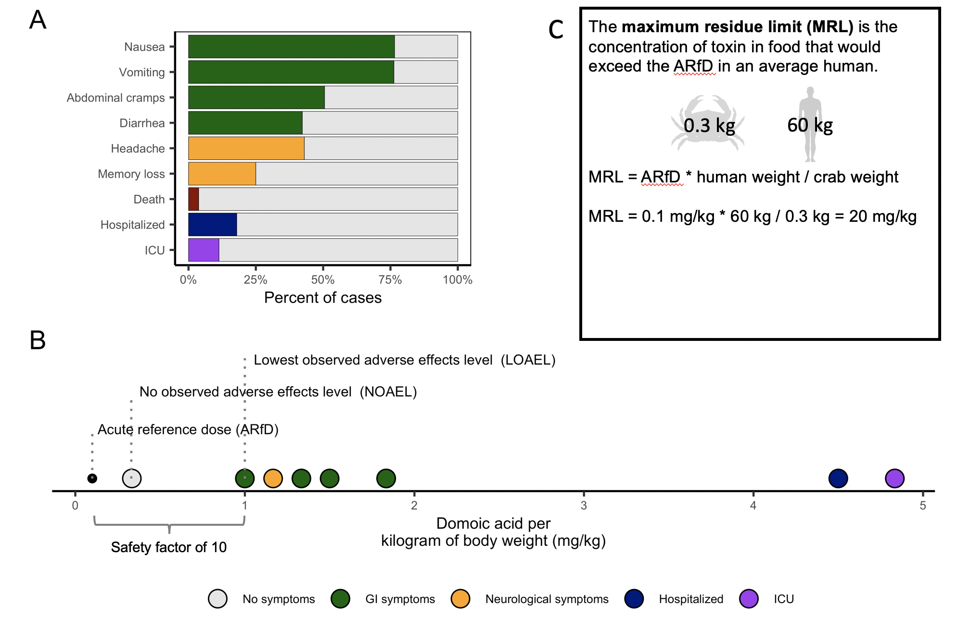**Box 1.** The origin of the domoic acid action threshold for Dungeness crab. Following the 1987 amnesic shellfish poisoning outbreak in eastern Canada, Perl et al. (1990) identified 107 cases of illness resulting from the consumption of contaminated mussels and **(A)** cataloged the symptoms experienced by 99 of these patients and the treatment protocols for 106 patients. For 9 of these patients, Perl et al. (1990) were able to determine **(B)** the amount (mg) and dosage (mg/kg of body weight) of domoic acid consumed by the patient. These dosages were used by a Joint FAO/WHO/IOC Expert Working Group to derive toxicological reference points for domoic acid consumption [(Toyofuku, 2006)](https://www.zotero.org/google-docs/?1MByBm). The acute reference dose (ARfD), the amount of a substance that can be consumed in a meal or day without appreciable health risk to the consumer, was set by dividing the lowest observed adverse effect level (LOAEL) by a safety factor of 10. The maximum residue limit, which serves as the action threshold, was then derived as described in **(C)**. See Toyofuku (2006) for a detailed summary.

To-do list:

1. Make panel C prettier and more clear
2. Explain 30 ppm in viscera

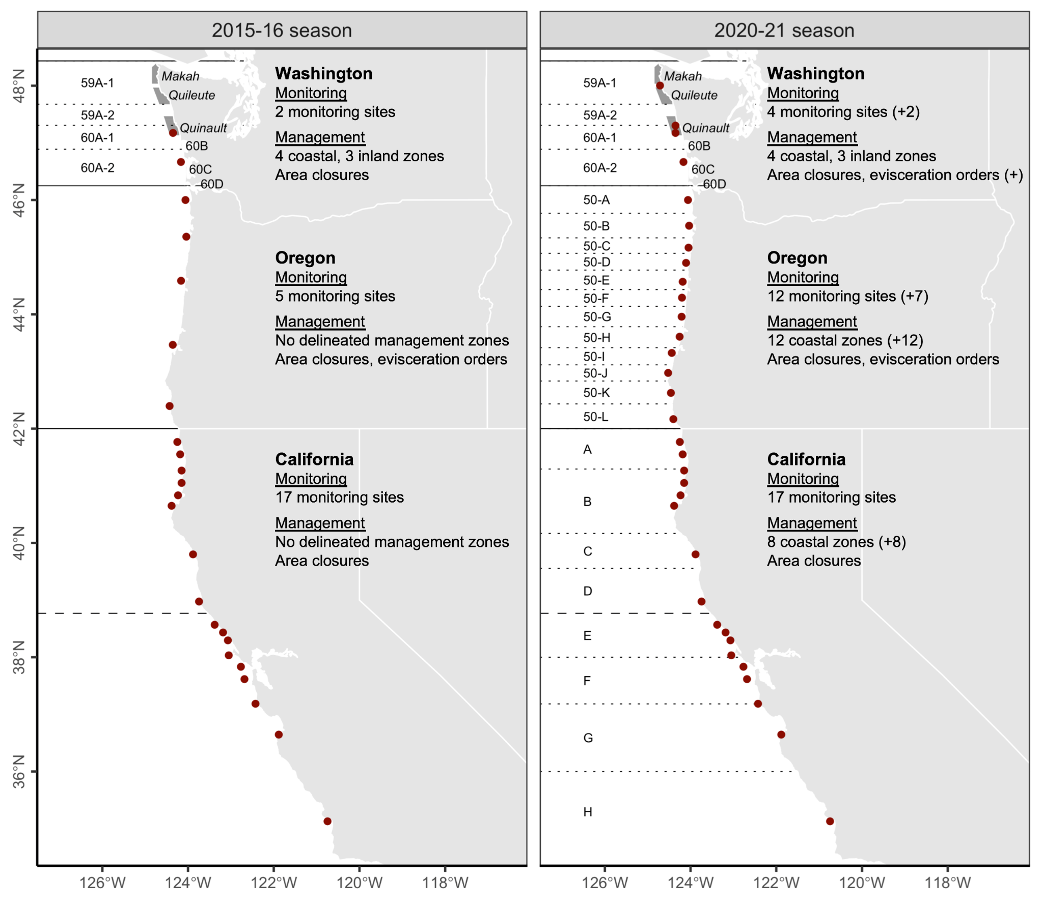**Figure 1.** Dungeness crab domoic acid monitoring sites, management zones, and action options along the U.S. West Coast before the 2015-16 and 2020-21 seasons. Since the 2015-16 season, state agencies have added 9 monitoring sites and delineated 20 monitoring zones along the coast. Solid black lines indicate state borders, dotted lines indicate biotoxin management zones, and the dashed line indicates the boundary between the Northern and Central California management regions. In Washington, zones 60B, 60C, and 60D are the semi-enclosed coastal bays of Grays Harbor, Willapa Bay, and the Columbia River, respectively. At-sea shaded polygons and italic text indicate Special Management Areas (SMAs) that are co-managed by state and treaty tribe managers.

### 

**Figure 2.** Results of coastal Dungeness crab domoic acid monitoring surveys on the U.S. West from 2014-2021. A survey (circles) is defined as a group of five or more individuals samples collected at the same location on the same day. Solid black lines indicate state borders and the dashed line indicates the border between the Northern and Central California management zones. Grey shading indicates the commercial Dungeness crab fishing season in each region. Grey lines indicate the biotoxin management zones established in Washington several decades ago, in Oregon before the 2017-18 season, and in California before the 2020-21 season. The labeled points highlight the following notable events: (1) elevated and extended contamination in California relative to southern Oregon; (2) elevated late season contamination in Washington; elevated mid-season contamination Oregon observed by (3) coarse and (4) resolved monitoring systems; and (5) elevated early season contamination in Washington.

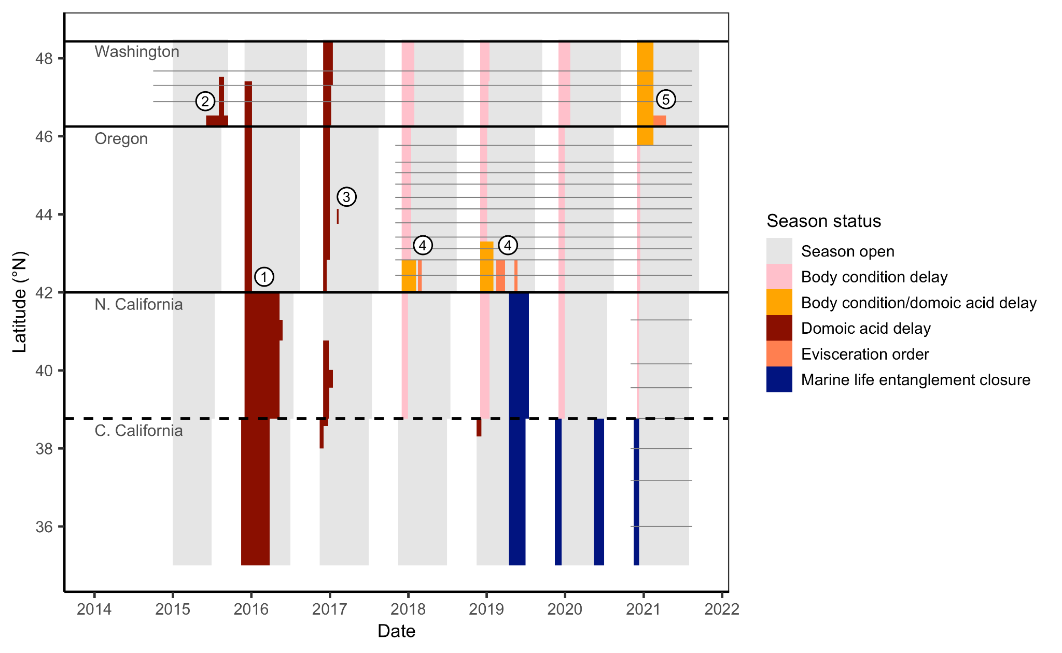**Figure 3.** Timeline of coastal fishery closures in the commercial Dungeness crab fishery on the U.S. West Coast from 2014-2021. Grey shading indicates when the season is open and other colors indicate a closure and its cause. Solid black lines indicate state borders and the dashed line indicates the border between the Northern and Central California management zones. Grey lines indicate the biotoxin management zones established in Washington several decades ago, in Oregon before the 2017-18 season, and in California before the 2020-21 season. The labeled points highlight the following notable events: (1) extended closures in California relative to southern Oregon; (2) late season biotoxin closure in Washington, (3) mid-season biotoxin closure in Oregon; (4) mid-season evisceration orders in Oregon; and (5) the first evisceration order in Washington.

To-do list:

1. Fix CA closures that are DA/body condition

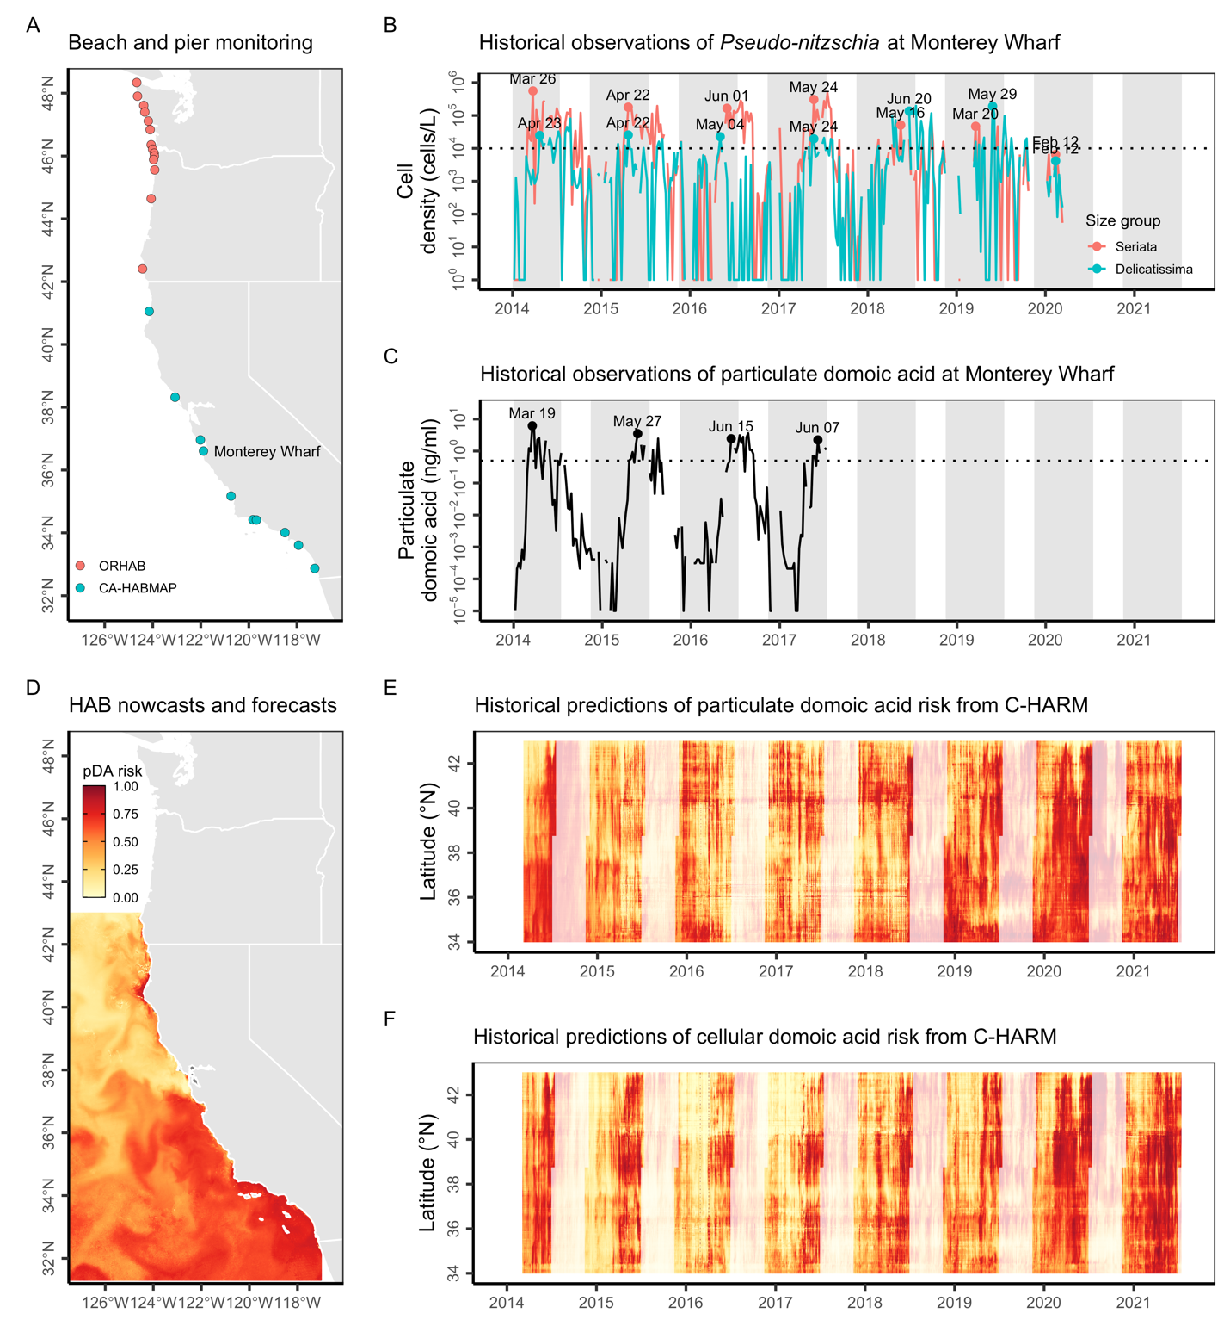**Figure 4.** Historical indicators of potential mid-season domoic acid risk in the commercial California Dungeness crab fishery. Panel **(A)** shows the location of historical *Pseudo-nitzschia* and particulate domoic acid monitoring at piers and beaches along the West Coast. Panels **(B)** and **(C)** show historical *Pseudo-nitzschia* and particulate domoic acid densities, respectively, at Monterey Wharf in California. In **(B)**, colored lines indicate the density of *Pseudo-nitzschia* in the smaller ‘delicatissima’ (<3 μm valve width) and the larger and more toxigenic ‘seriata’ (>3 μm valve width) size classes; the dotted black line indicates the 10,000 cells/L bloom threshold used by C-HARM. In **(C)**, the dotted black line indicates the 0.5 ng/ml threshold for elevated pDA risk used by C-HARM. In both panels, the grey shading indicates the commercial Dungeness crab fishing season and the labels mark in-season peaks in HAB risk. Panel **(D**) illustrates an example prediction of particulate domoic acid (pDA) risk from C-HARM. Panels **(E)** and **(F)** illustrate mean daily particulate domoic acid and cellular domoic acid risk, respectively, within Dungeness crab fishing grounds (<100 fathoms) along latitudinal bands. In both panels, non-transparent hues indicate the commercial Dungeness crab fishing season.

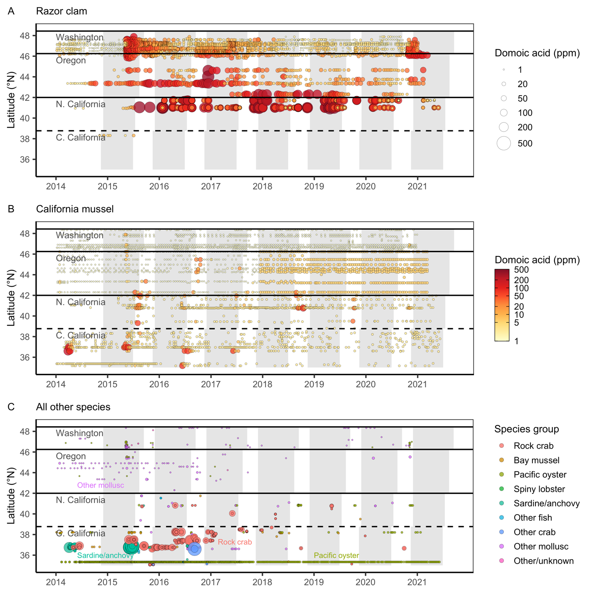**Figure 5.** Domoic acid contamination in **(A)** razor clam (*Siliqua patula*), **(B)** California mussel (*Mytilus californianus*), and **(C)** other species on the U.S. West Coast relative to the commercial Dungeness crab fishing season. Solid black lines indicate state borders. Solid black lines indicate state borders and the dashed line indicates the border between the Northern and Central California management zones. Grey shading indicates the commercial Dungeness crab fishing season in each region. See **Table S2** for the species included in each species group.

To-do list:

* Make points larger
* Log-scale and 1, 5, 10, 20, 50, 100, 200, 500 breaks?

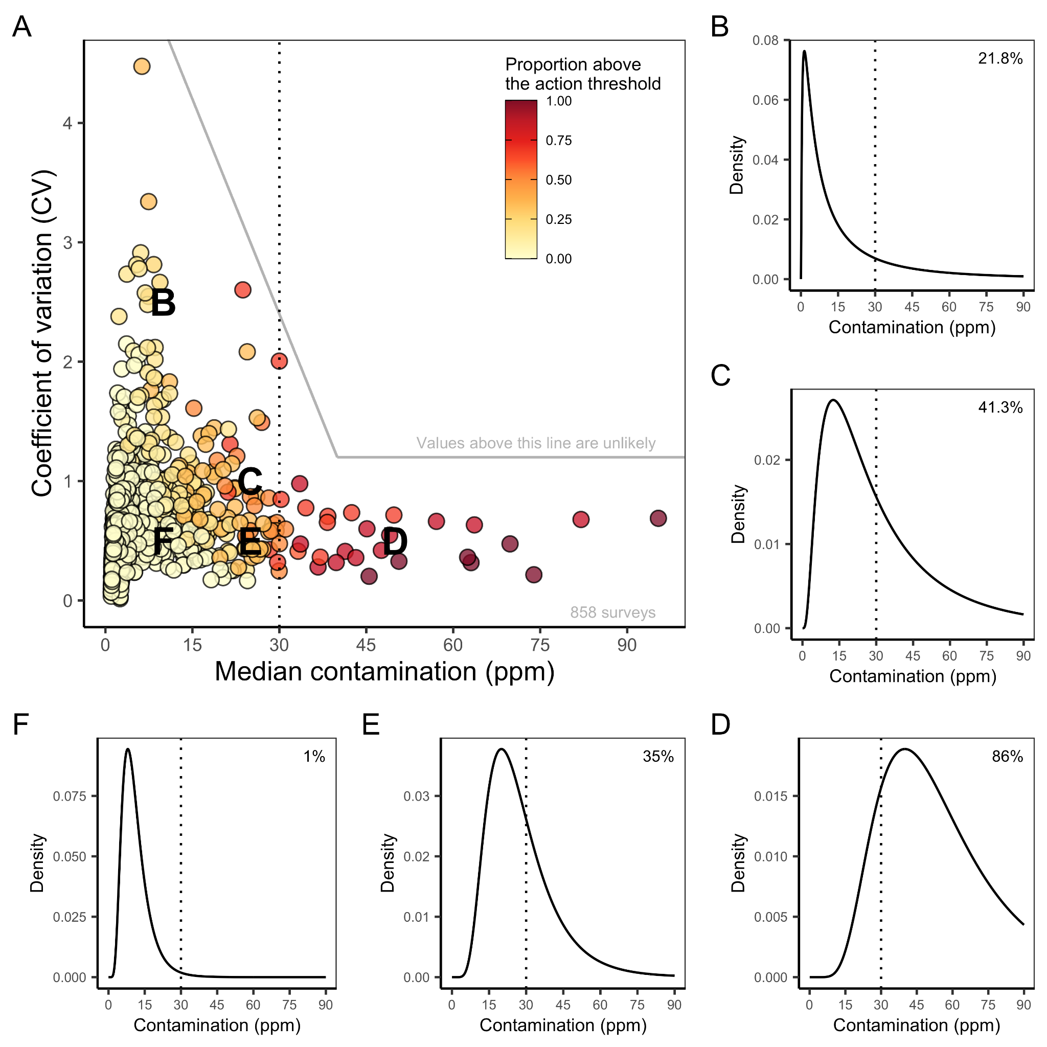

**Figure 6.** Distributions of domoic acid contamination in sampled Dungeness crab viscera in 858 biotoxin surveys (≥ 6 crabs per survey) conducted on the U.S. West Coast from 2015-2021. In **(A)**, each point represents the scale (median) and shape (CV) of a log-normal distribution fit to the results of each survey. Points are colored based on the observed proportion of samples testing above the 30 ppm action threshold (vertical dotted line, in all panels). The solid grey lines delineate unlikely contamination distributions based on historical monitoring; values above these lines are not considered in simulation testing (see **Figure 8**). The letters indicate the scale and shape of the five example domoic acid contamination distributions illustrated in **B-C**. In **B-C**, percentages indicate the percent of crabs testing above the 30 ppm action threshold.

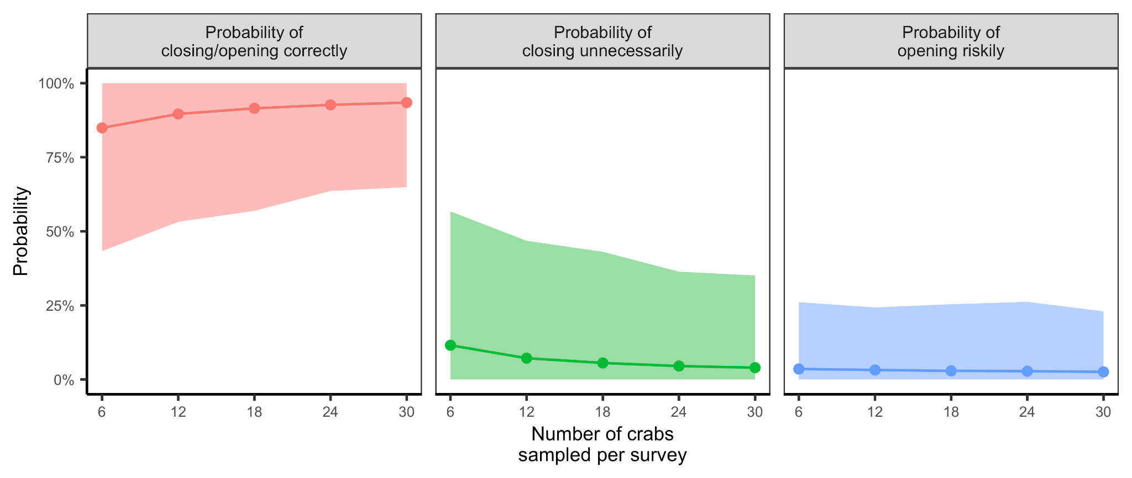**Figure 7.** The power for domoic acid monitoring programs of varying sample sizes to correctly diagnose contamination rates and recommend management actions. Probabilities represent the proportion of 1,000 surveys made for each of the 146 evaluated contamination profiles (defined by unique combinations of centrality-variability parameters), in which the survey correctly diagnosed the true level of contamination as requiring (≥1 in 6 crabs above the 30 ppm action threshold) or not requiring (<1 in 6 crabs above the action threshold) management action. The points illustrate the mean probabilities across the 146 evaluated contamination profiles and the shading indicates the inner 90th percentile of these values. Unnecessary closures occur when a survey deems that management action is necessary when it is not and risky openings occur when a survey deems that management action is not necessary when it is (**Table S6**).

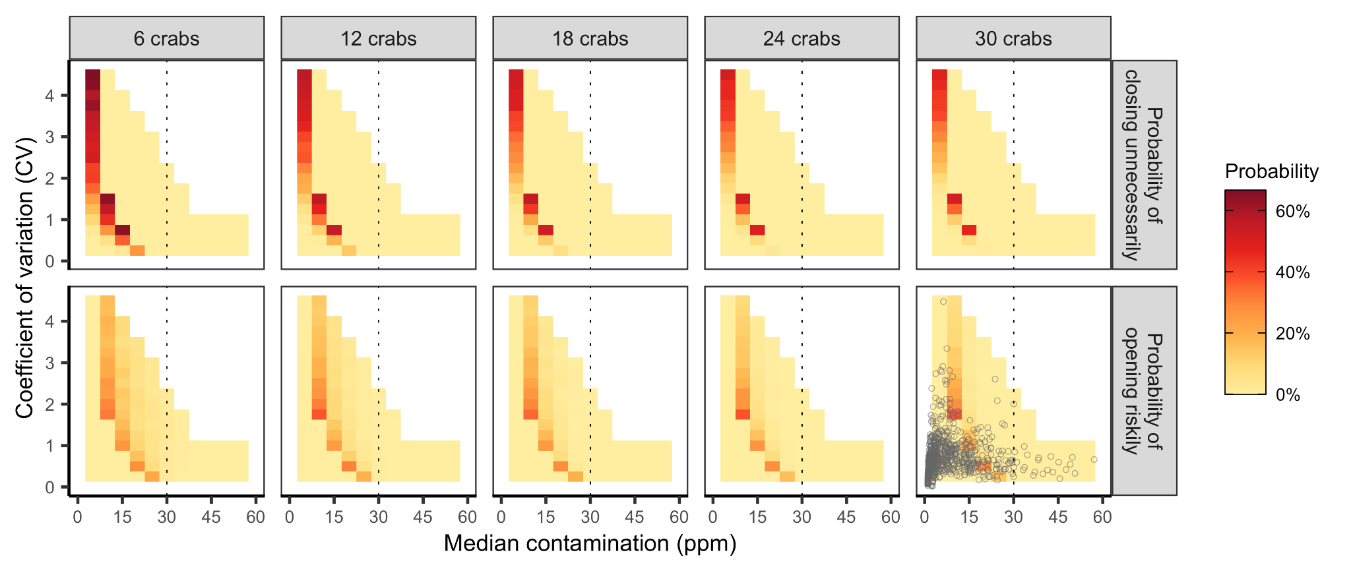**Figure 8.** The simulated risk of making an incorrect management decision based on the number of crabs sampled in a survey and the distribution of domoic acid contamination in the sampled population. Risk is measured as the probability of unnecessarily delaying a season opening when levels are actually below the action threshold (top row) and as the probability of opening the season when levels are actually above the action threshold (bottom row). Probabilities are determined based on the outcomes of 1,000 randomized simulations. The white cells were not evaluated because they represent unlikely contamination distributions based on historical observations (points in lower right corner; see **Figure 6** for additional information). Correct management decisions were nearly universal when median contaminations were above 60 ppm; thus, to highlight results at more challenging levels of contamination (0-30 ppm), results between 60-100 ppm are not plotted here.

### Supplemental Tables and Figures

#### Supplemental Tables

**Table S1.** Dungeness crab domoic acid contamination monitoring and management program design in California, Oregon, and Washington before the 2020-21 and 2015-16 seasons (2015-16 season values are provided in parentheses if different from the 2020-21 season).

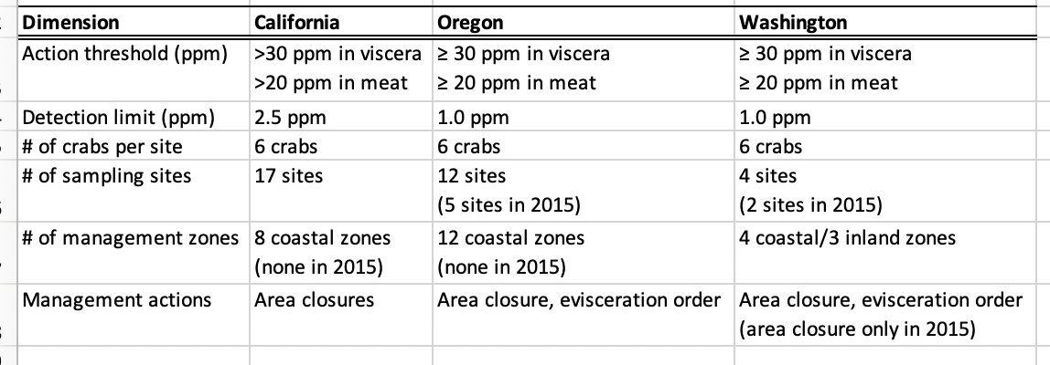

**Table S2.** Number of domoic acid tests by species from 2014-2021 on the U.S. West Coast.

|  |  |  |
| --- | --- | --- |
| **Common name (scientific name)** | **States** | **# of samples** |
| Dungeness crab (Metacarcinus magister) | CA/OR/WA | 6237 |
| California (sea) mussel (Mytilus californianus) | CA/OR/WA | 3733 |
| Razor clam (Siliqua patula) | CA/OR/WA | 2783 |
| Rock crab (Cancer spp.) | CA | 1458 |
| Pacific oyster (Crassostrea gigas) | CA/OR/WA | 901 |
| Mediterranean (bay) mussel (Mytilus galloprovincialis) | CA | 538 |
| California spiny lobster (Panulirus interruptus) | CA | 185 |
| Red rock crab (Cancer productus) | CA | 109 |
| Pacific sardine (Sardinops sagax) | CA | 80 |
| Northern anchovy (Engraulis mordax) | CA | 68 |
| Rock scallop (Crassadoma gigantea) | CA | 43 |
| Purple varnish clam (Nuttallia obscurata) | OR | 35 |
| Blue mussel (Mytilus trossulus) | WA | 33 |
| Eastern softshell clam (Mya arenaria) | OR | 25 |
| Sheep (spider) crab (Loxorhynchus grandis) | CA | 23 |
| Pismo clam (Tivela stultorum) | CA | 22 |
| Brown rock crab (Romaleon antennarius) | CA | 21 |
| Yellow rock crab (Metacarcinus anthonyii) | CA | 20 |
| Manila clam (Ruditapes philippinarum) | CA/WA | 19 |
| Gaper (horse) clam (Tresus capax/nuttallii) | CA/OR/WA | 18 |
| Stone crab | CA | 18 |
| Cockle (Clinocardium nuttallii) | CA/OR | 17 |
| Barred surfperch (Amphistichus argenteus) | CA | 8 |
| Pelagic red crab (Pleuroncodes planipes) | CA | 8 |
| Red abalone (Haliotis rufescens) | CA | 8 |
| Mackerel (Scombridae spp.) | CA | 7 |
| Black surfperch (Embiotoca jacksoni) | CA | 6 |
| Pile surfperch (Rhacochilus vacca) | CA | 4 |
| Unknown | OR/WA | 4 |
| Washington clam (Saxidomus nuttalli) | CA | 4 |
| Butter clam (Saxidomus gigantea) | CA/OR | 3 |
| Pacific lamprey (Entosphenus tridentatus) | CA | 3 |
| Kumamoto oyster (Crassostrea sikamea) | CA | 2 |
| Littleneck clam (Leukoma staminea) | CA/OR | 2 |
| Shiner surfperch (Cymatogaster aggregata) | CA | 2 |
| Barnacle | WA | 1 |
| Bay clam spp. | OR | 1 |
| Bay mussel (Mytilus edulis) | OR | 1 |
| California market squid (Doryteuthis opalescens) | CA | 1 |
| California yellowtail (Seriola lalandi) | CA | 1 |
| Swimming crab (Portunus xantusii) | CA | 1 |

**Table S3.** Sources of news releases describing closures, advisories, and other management actions related to biotoxin contamination on the U.S. West Coast.

|  |  |  |
| --- | --- | --- |
| **State** | **Type** | **Link** |
| OR | Dungeness crab | <https://www.dfw.state.or.us/MRP/shellfish/commercial/crab/news_publications.asp> |
| OR | ODFW news releases | <https://www.dfw.state.or.us/news/2021/index.asp> |
| OR | ODA news releases | <https://odanews.wpengine.com/tag/shellfish/page/4/> |
| CA | CDFW news releases | <https://cdfwmarine.wordpress.com/2020/> |
| CA | CDPH news releases | <https://www.cdph.ca.gov/Programs/OPA/Pages/New-Release-2020.aspx> |
| CA | CDPH shellfish advisories | <https://www.cdph.ca.gov/Programs/OPA/Pages/Shellfish-Advisories.aspx> |
| PSMFC | Dungeness crab | <http://www.psmfc.org/crab/> |
| WA | Dungeness Crab | <https://wdfw.wa.gov/fishing/commercial/crab/coastal/letters-notices> |

**Table S4.** Latitudinal density of domoic acid monitoring sites for Dungeness crab by state.

|  |  |  |  |  |
| --- | --- | --- | --- | --- |
| **State** | **Lat. range** | **Lat. height** | **2015-16 site density** | **2020-21 site density** |
| Washington | 46.25° - 48.43°N | 2.18° | 2 sites, 1 per 1.09°N | 4 sites, 1 per 0.55°N |
| Oregon | 42.00° - 46.25°N | 4.25° | 5 sites, 1 per 0.85°N | 12 sites, 1 per 0.35°N |
| California | 35.00° - 42.00°N | 7.00° | 17 sites, 1 per 0.41°N | 17 sites, 1 per 0.41°N |

**Table S5.** “3S” management (sex-size-season) of commercial and recreational Dungeness crab fishing in California, Oregon, and Washington.

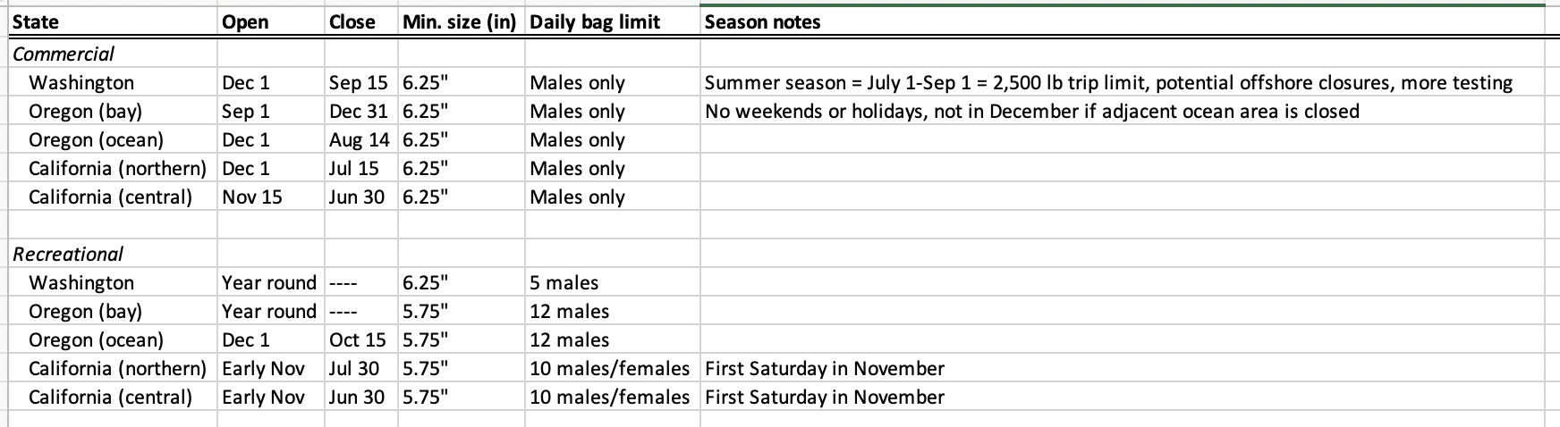

**Table S6.** A guide to interpreting the results of the power analysis.

**​​**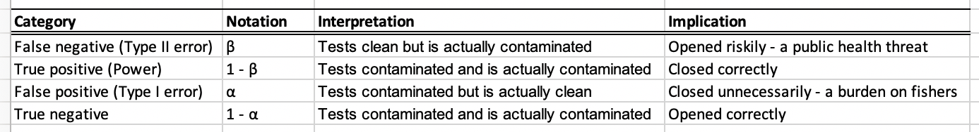

1 Negative test = clean test; Positive test = contaminated test

2 Clean = <1 in 6 crabs above threshold; Contaminated = ≥1 1 in 6 crabs above threshold

#### Supplemental Figures

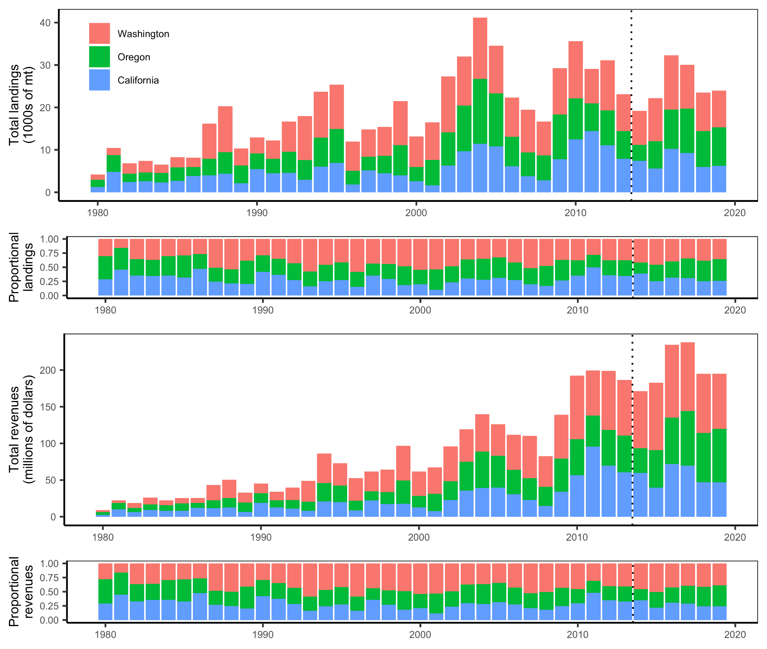**Figure S1.** Landings and revenues from the commercial Dungeness crab fishery by season and state from the 1980-81 season to the 2019-20 season. The data are from the PacFIN database. The dotted vertical line indicates the start of the 2014-15 season.

#### 

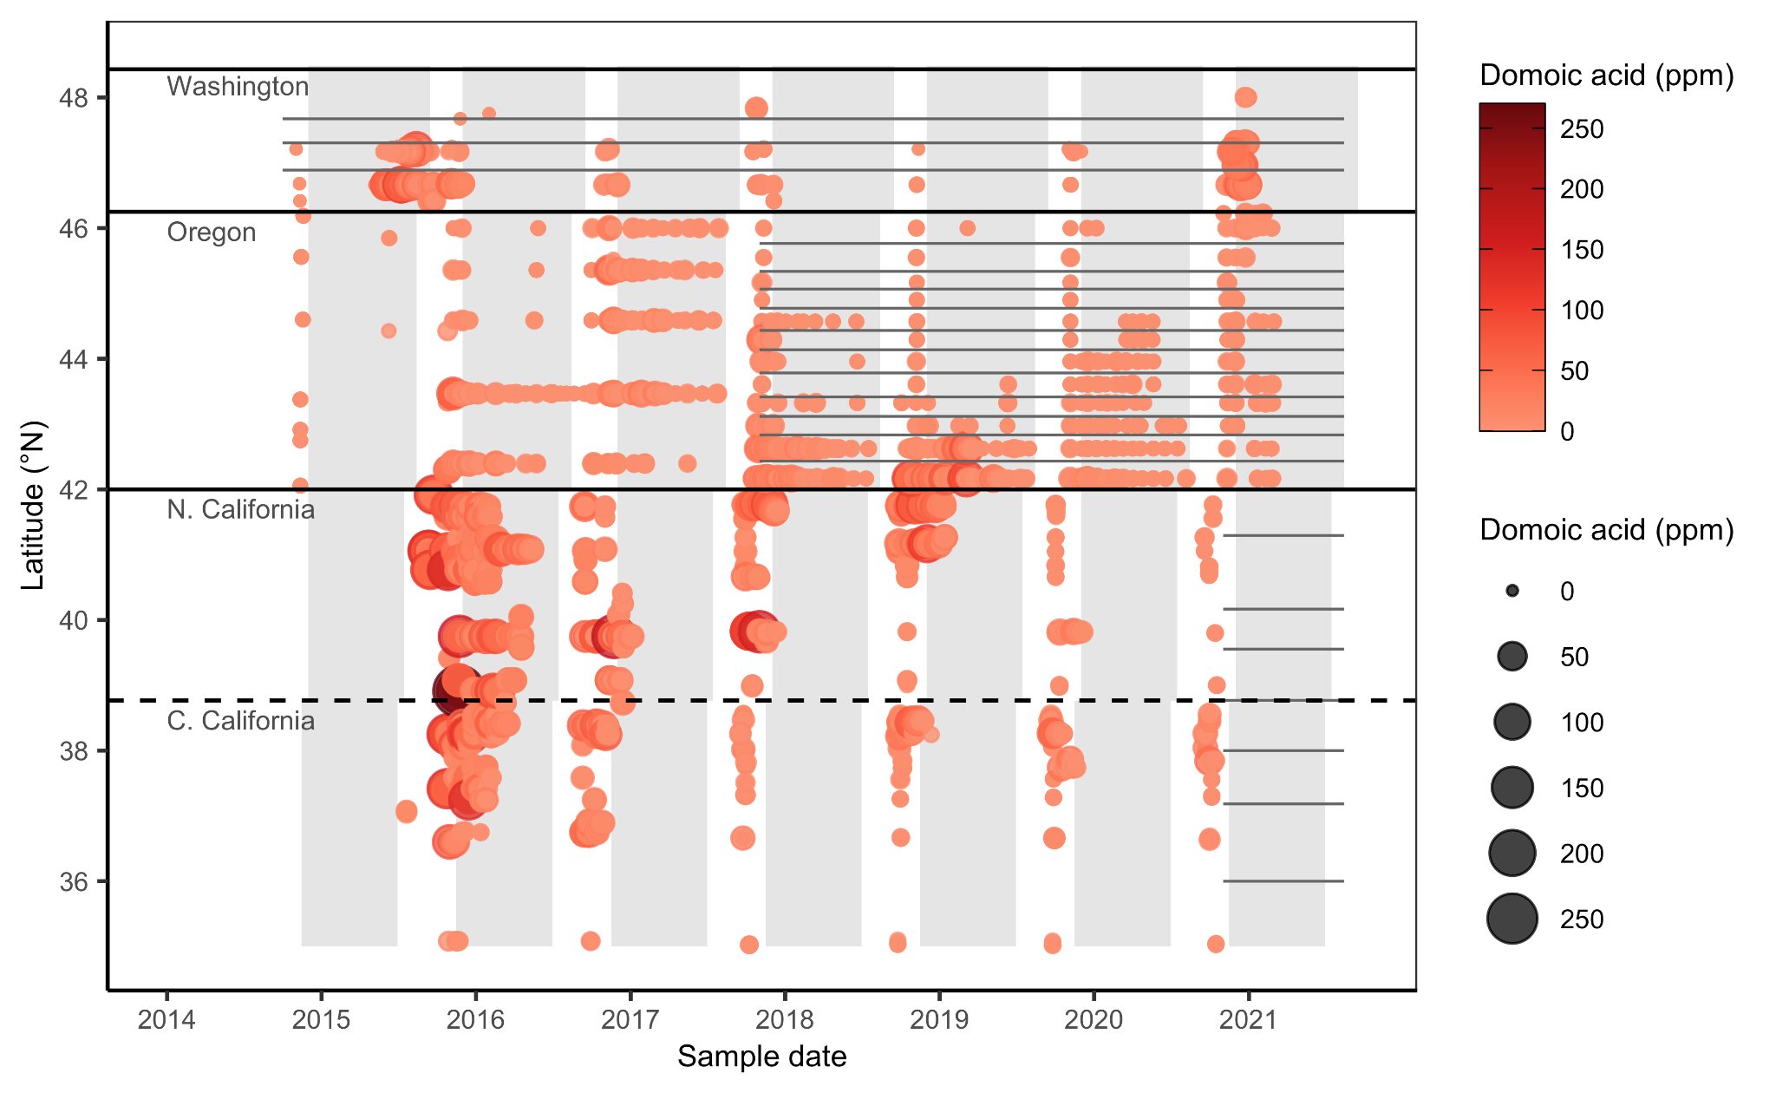

**Figure S2.** Results of domoic acid testing for Dungeness crab on the U.S. West Coast from 2014-2021. Solid black lines indicate state borders and the dashed line indicates the border between the Northern and Central California management zones. Grey shading indicates the commercial Dungeness crab fishing season in each region. Grey lines indicate the biotoxin management zones established in Washington several decades ago, in Oregon before the 2017-18 season, and in California before the 2020-21 season.

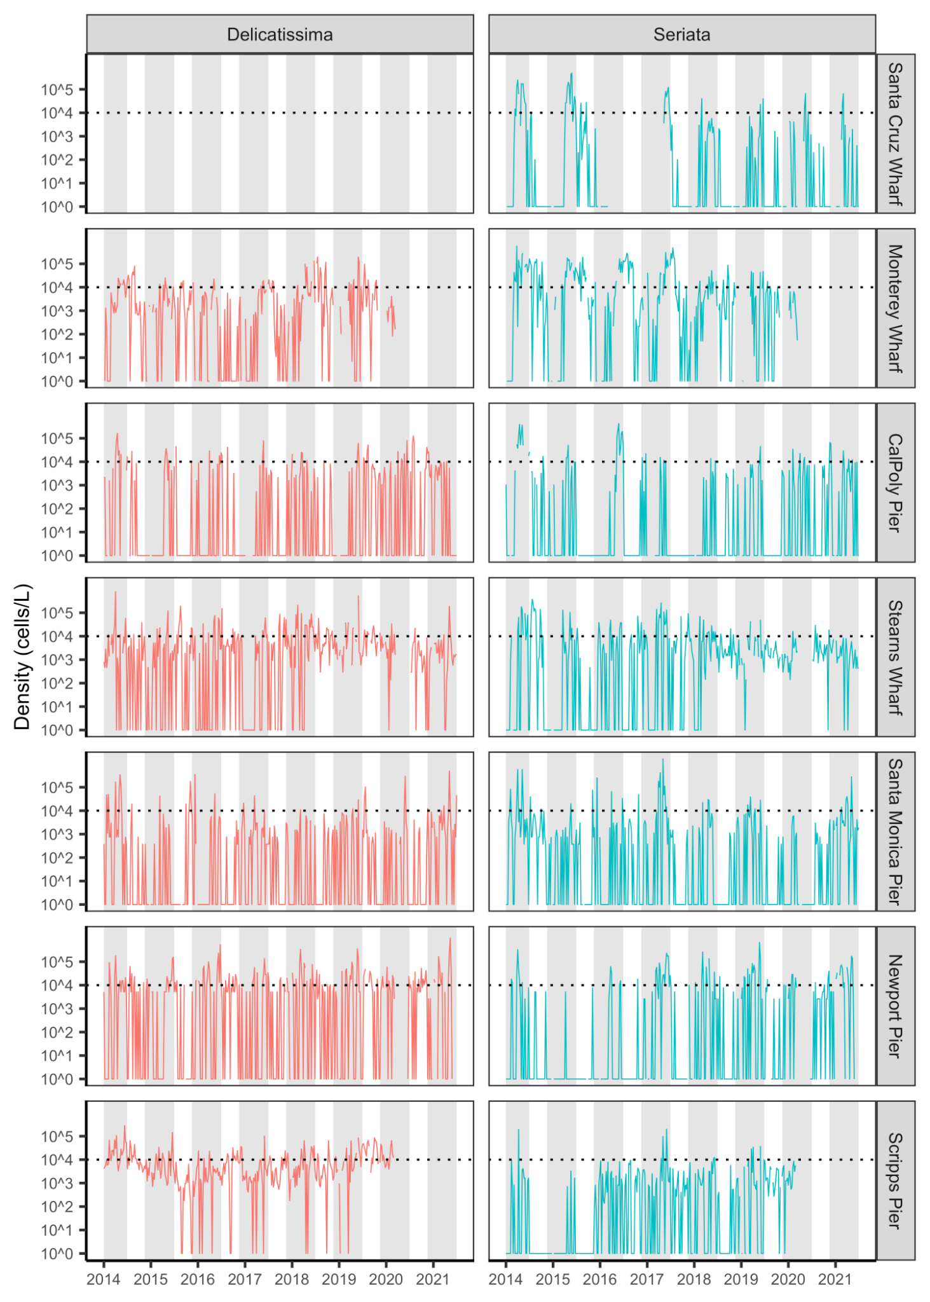

**Figure S3.** Weekly density of *Pseudo-nitzschia* in the smaller ‘delicatissima’ (<3 μm valve width) and larger ‘seriata’ (>3 μm valve width) size classes [(Bowers et al., 2018)](https://www.zotero.org/google-docs/?trtpJA)at seven piers in California from 2014-2021. *Pseudo-nitzschia* in the seriata size class are considered more toxigenic. The dotted horizontal lines indicate the 10,000 cells/L bloom thresholds of [(Anderson et al., 2011)](https://www.zotero.org/google-docs/?JwW09o). Grey shading indicates the commercial Dungeness crab fishing season in the central region. Piers are ordered from north to south. Data from Trinidad Pier and Goleta Pier are publicly available from SCCOOS but are not plotted due to their limited temporal coverage. Data are collected from Bodega Bay but are not publicly available.

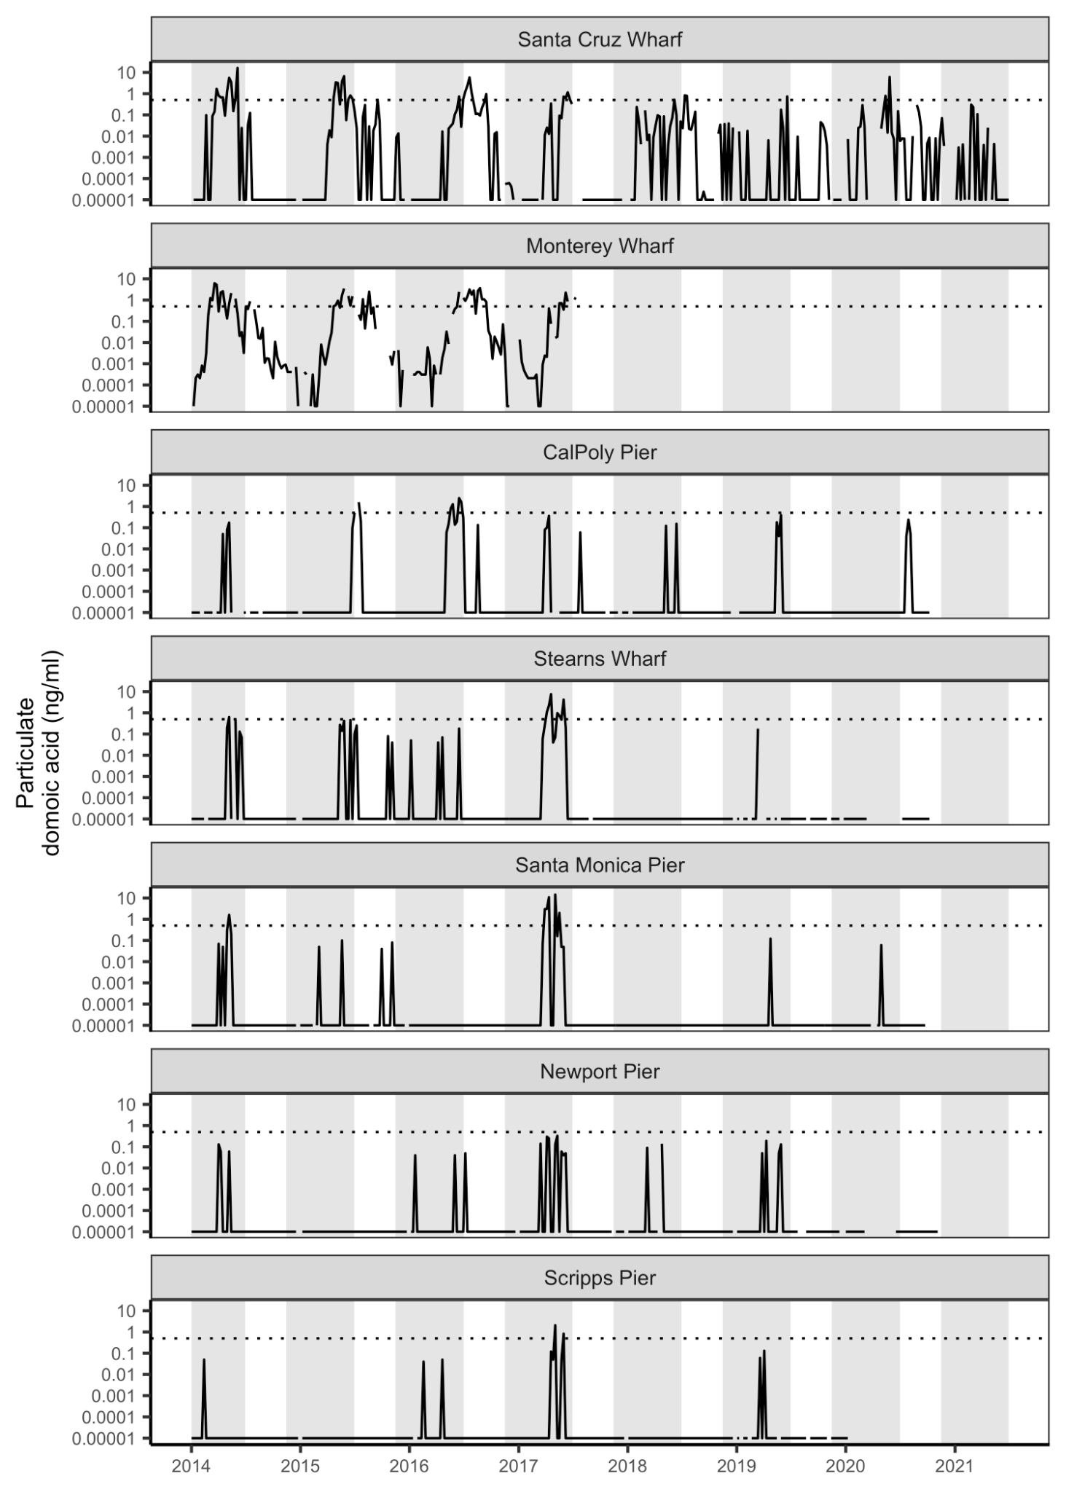

**Figure S4.** Weekly particulate domoic acid (pDA) concentrations at seven piers in California from 2014-2021. The dotted horizontal lines indicate the 0.5 ng/ml threshold for elevated pDA risk used by [(Anderson et al., 2011)](https://www.zotero.org/google-docs/?iL6CiC). Grey shading indicates the commercial Dungeness crab fishing season in the central region. Piers are ordered from north to south. Data from Trinidad Pier and Goleta Pier are publicly available from SCCOOS but are not plotted due to their limited temporal coverage. Data are collected from Bodega Bay but are not publicly available.

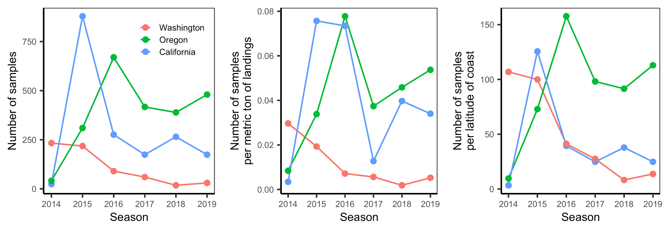**Figure 4.** Number and density of Dungeness crab domoic acid samples by state and season.

1. Harmful Algal Bloom Monitoring and Alert Program (HABMAP): https://calhabmap.org/
2. Southern California Coastal Ocean Observing System (SCCOOS): https://erddap.sccoos.org/erddap/
3. Olympic Region Harmful Algal Bloom (ORHAB) Partnership: http://orhab.org/
4. CA HAB Bulletin: ​​https://sccoos.org/california-hab-bulletin/
5. Pacific Northwest HAB Bulletin: https://depts.washington.edu/orhab/pnw-hab-bulletin/